Sample of the book

Introducing Systematic Simplicity to Manage Decisions
How a Systematic Simplicity Approach Builds Clarity about Opportunity,
Risk and Uncertainty Essential to All Best Practice Decision Making

by

Chris Chapman,
Emeritus Professor of Management Science, Southampton Business School,
University of Southampton, Southampton SO17 1BJ, UK.

Published in 2021 by UK Book Publishing
305 Whitley Road, Whitley Bay, Tyne and Wear, NE 26 2HU, UK.

This 80 page sample provides a version of the book’s contents page on page 2 which uses bold font and provides page numbers to indicate all the material included in the sample (material not included in the sample is not in bold font and no sample page numbers are provided). To facilitate this approach the author’s final draft prior to type setting has been used, so figure/text layouts are not the same as the printed or eBook versions.

Copyright © 2021 Chris Chapman
The moral right of this author has been asserted.
All rights reserved.

You are welcome to copy this book sample for private and other non-commercial use, provided you respect the author’s copyrights and the copyrights of the diagram’s publishers. Taylor and Francis Group, LLC, a division of informa plc, have kindly granted permission to reproduce variants of diagrams used in their Routledge imprint book Enlightened Planning in the book Introducing Systematic Simplicity to Manage Decisions.

Contents

page

Dedication 3
Foreword by Stephen Ward 4
Preface and introduction 5

Part 1 Introducing efficiency and decomposition concepts 10

- A minimum clarity estimation approach and the clarity efficiency concept 11
- A simple opportunity efficient approach to seeking risk efficiency 26
3 High clarity decomposition of sources of uncertainty for contingency planning 37
4 A high clarity demonstration of risk efficiency and enlightened caution 46
5 Enlightened gambles and enlightened prudence 50
6 Bias as a symptom of multiple sources of opportunity inefficiency that matter 55

Part 2 Making systematic simplicity operational on a corporate basis

7 A universal process (UP) concept
8 Project management: frameworks, processes and models
9 Corporate strategy formation frameworks
10 Operations management and further corporate management concerns
11 Evolving a corporate commitment to systematic simplicity

Part 3 Key areas of focus for further enhancement of understanding and capability

12 Discounted cash flow analysis
13 Important trade-off clarifications involving ethical concerns
14 Related regulatory, legal and political concerns
15 Concluding reflections

Endorsements from a range of perspectives for the book Enlightened Planning 63
About the author 73
Acknowledgements
References 78
Website information

Dedication

This book is dedicated to everyone who is interested in user friendly approaches
to keeping it simple in a well-grounded and defensible best practice sense when making any kinds of decisions that really matter
as well as other more routine decisions that
may not matter very much.

Foreword by Stephen Ward

Whatever your background education and experience or areas of current primary interest, this book can change your view of what ‘to manage decisions’ ought to involve, and introduce you to valuable practical tools.

Most important decisions with significant consequences are not simple to make. Often the nature and consequences of potential decision options are very complex, and significant uncertainty about possible trade-offs between various performance criteria is involved. In such cases keeping things simple is an attractive proposition. But simplification which obscures important considerations and misrepresents key interactions and trade-offs can be seriously misleading and counterproductive.

When illustrating the systematic simplicity approach Chris Chapman explains how to pursue the right kind of simplifications – those that facilitate insightful analysis of key issues and lead to better decisions. A central feature of the approach is effective and efficient deconstruction of key factors in ways that maximise clarity for a given level of effort.

Part 1 examples drawn from decades of consulting work and reflection initiate illustration of what is involved. Key concepts are demonstrated in a recommended approach to achieving unbiased estimates, meaningful target setting, and making choices based on efficient trade-offs between all relevant aspects of performance together with associated risk. Part 2 outlines how systematic simplicity can be applied in corporate, project and operations management contexts, discussing the processes underlying Part 1 with additional detail and examples. The general applicability of systematic simplicity concepts is further illustrated by Part 3 case studies addressing difficult trade-offs inherent in appropriate discounting of future cash flows, valuing the risk of fatalities and injuries in safety contexts, and scoping the role of requirements for appropriate regulation of commercial organisations.

Modest opportunities involving routine decisions also need a systematic simplicity approach. Ultimately, the goal of any systematic simplicity application is effective and efficient pursuit of all available opportunities to make smarter decisions that can be identified or created by an enhanced understanding and better treatment of uncertainty and risk.

Stephen Ward is Emeritus Professor in Management,
Southampton Business School,
University of Southampton.

Preface and introduction

Most decision makers want to ‘keep it simple’ in an appropriate way in all decision making contexts. However, even corporate boards and government bodies making extremely important decisions often ‘keep it simple’ in ways which guarantee serious mistakes, and less important routine decisions frequently waste time and effort in predictable ways. Usually this is at least in part because senior managers and their supporting planners, analysts and other advisors routinely ‘keep it simple’ in common practice frameworks which deal with both working assumptions and framing assumptions in a defective manner. Helping to replacing this defective common practice with much better practice is this book’s overall purpose.

Choosing the ‘right kind’ of simplicity in all decision making contexts is not easy. However, failing to do so can be seriously damaging. The lack of a well-grounded, rigorously tested and generally applicable ‘best practice’ literature to support practitioners involves a wide range of issues which this book addresses using a ‘systematic simplicity’ approach. There are no ‘silver bullets’, but some approaches are much better than others, and we need to seek the best.

A useful starting point for adopting a ‘systematic simplicity’ approach is making a commitment to avoid all simplistic approaches which mislead and confuse. A central underlying concern is making full use of all the opportunities available to use the ‘right’ simplifying assumptions, avoiding any significant risks associated with making the ‘wrong’ simplifying assumptions, as part of seeing the management of all aspects of opportunity as a primary goal, avoiding all relevant risk as a closely-coupled second order goal. A key issue is always asking the ‘right’ questions and consistently getting ‘good’ answers, defining ‘good’ answers to the ‘right’ questions as ‘fit for purpose’ in a way which is ‘best practice’ given the time and other resources available. Being ‘fit for purpose’ in this sense includes being ‘user friendly’ for everyone involved in an effectively balanced manner, but always avoiding inappropriate ‘dumbing down’ of the approach taken.

The first and overriding goal for this book is persuading you that the systematic simplicity approach explored and promoted by this book can yield much better decisions for a lot less effort than a lot of common practice in any context, including some of your personal and family decisions, although decision making by organisations is the focus.

The closely-coupled second order goal for this book is convincing you that it would be a good idea to help any organisations of interest to you introduce and continue to develop a systematic simplicity approach. These ‘organisations of interest’ may be commercial organisations (private sector or public sector), or public sector organisations with no commercial goals, or third sector organisations like charitable trusts.

A basic tenet of a systematic simplicity approach is always using words in a plain English sense without resorting to technical terminology unless a technical interpretation is useful. Associated tenets are all technical terminology framing assumptions should generalise as far as possible, never inappropriately restrict, and usefully restrictive closely-coupled working assumptions should be clarified and tested appropriately.

For example, the word ‘clarity’ as used in this book’s subtitle can be given a plain English meaning with no restrictions, but when used in the context of the term ‘clarity efficiency’, ‘clarity’ means ‘relevant insight which can be communicated effectively to everyone who needs to understand’. The term ‘clarity efficient’ means ‘a maximum level of “clarity” (relevant insight which can be communicated effectively to everyone who needs to understand) for any given level of effort and associated cost’. ‘Clarity efficiency’ is a central systematic simplicity concept, initially explored and illustrated in Chapter 1.

The words ‘opportunity’, ‘risk’ and ‘uncertainty’ as used in this book’s subtitle can all be given plain English meanings which are not restrictive, and linked technical concept working assumptions are important. In these three cases it is important to understand from the outset that technical definitions treated as framing assumptions for several common practice approaches are explicitly rejected because they are inappropriately restrictive.

‘Framing assumptions’ are deeply embedded ‘deciding how to decide’ assumptions at several interdependent foundation levels which shape the way we see the world. They are inherently difficult to identify, understand, test and revise. ‘Working assumptions’ are usually much easier to identify, understand, test and revise, but this is not always done effectively or efficiently. The way framing and working assumptions are addressed is a central issue in this book – when not of immediate concern, always an underlying consideration in the background.

A systematic simplicity approach defines the word ‘uncertainty’ in framing assumption terms as ‘lack of certainty’, a circular but simple plain English definition chosen to avoid any unintended restrictions. As working assumptions for analysis purposes, ‘uncertainty’ is sometimes usefully clarified by association with one or more of five portrayals:
- variability uncertainty (inherent or the result of composing different sources of uncertainty of any kind);
- event uncertainty (involving simple events or complex scenarios which may or may not happen, or assumptions which may or may not hold referred to as conditions);
- ambiguity uncertainty (which may involve underlying complexity not currently understood or a lack of information, both perhaps partially resolvable at a cost given time and other resources);
- capability-culture uncertainty (involving systems and people with the potential for surprises ranging from the implications of ill-designed computer systems to badly trained and poorly motivated staff doing wholly unpredictable things as well as reasonably predictable surprises);
- systemic uncertainty (involving interdependencies between any sources of uncertainty that have been decomposed which may be unknown and perhaps unknowable – if we take something apart (decompose it), when we put it back together again (recompose it), we have to address systemic uncertainty explicitly).

Sometimes it is useful to associate numeric probabilities with some or all of the uncertainty of interest, but sometimes a purely qualitative understanding is more useful. Drawing a boundary to distinguish between ‘risk’ and ‘uncertainty’ based on quantification or non-quantification is an inappropriately restrictive approach adopted by classical decision theory, rejected by modern decision theory 50 years ago, but still common practice. It is explicitly rejected by a systematic simplicity approach, consistent with modern decision theory as advocated by authors like Howard Raiffa (Raiffa, 1968). Some approaches to ‘risk’ limit their attention to ‘event uncertainty’, and some go even further and restrict their attention to expected outcomes associated with ‘event uncertainty’. Both of these positions are explicitly rejected by a systematic simplicity approach, consistent with a modern portfolio theory approach to ‘risk’ and all authors following variants of the ideas developed by Markowitz (1959).

Chapter 1 begins to explore and explain the implications of uncertainty, and Chapter 2 begins to explore and explain the implications of ‘risk’ and ‘opportunity’, but fully understanding ‘uncertainty’, ‘risk’ and ‘opportunity’ from a systematic simplicity perspective may require abandoning your current understanding of what these words mean in a technical sense, and you may need to read beyond the end of Part 1 before you start to become really comfortable with a new set of framing and working assumptions for uncertainty, risk and opportunity.

Effective communication and collaboration built upon well-founded trust are amongst the central goals of a systematic simplicity approach. When uncertainty is significant and important ethical issues are involved, the need for effective communication and collaboration built upon well-founded trust becomes particularly obvious, but understanding the value of trust and seeking to preserve trust in an effective and efficient manner is always important.

A holistic and pragmatic view of all relevant uncertainty and underlying complexity is central, as is understanding all associated opportunity and risk, viewing them all from the perspective of a fully generalised ‘risk efficiency’ framework. This is a core framing assumption.

The basic approach to ‘risk efficiency’ developed by Harry Markowitz in the 1950s won him the Nobel Prize for economics in 1990, and risk efficiency is now central to the foundations of portfolio theory in economics. But in effective fully generalised forms as part of a much broader ‘opportunity efficiency’ concept, risk efficiency should also be seen as central to the foundations of managing all aspects of any organisation’s project management, operations management and corporate management. This is not generally the case.

For this book’s purposes ‘risk efficiency’ means ‘a minimum level of risk for any given level of expected reward’, understanding that multiple ‘reward’ attributes may need attention, and some of these reward attributes may not be worth measuring, while measuring other reward attributes in a direct sense may not be feasible. Illustrative reward attribute examples include money (profit, contribution to profit or cost avoided), reputation in positive terms or loss of reputation avoided, fatalities avoided, injuries avoided, and environmental damage avoided.

A central part of the composite ‘opportunity efficiency’ concept needed to achieve an effective fully generalised risk efficiency concept is a fully embedded ‘clarity efficiency’ concept, already defined above.

Another central part of achieving ‘opportunity efficiency’ involves obtaining the most appropriate trade-offs between risk and expected reward for all reward attributes of interest assuming risk efficiency in terms of each attribute, plus the most appropriate trade-offs between attributes, including trade-offs between clarity and the effort/cost involved in a multiple attribute clarity efficient sense.

Achieving opportunity efficiency in this sense is clearly an exceedingly demanding goal. Even understanding what is involved is not straightforward. But doing our best to understand what is involved, and doing our best to achieve ‘best practice’ defined in terms of what ought to be done in these terms, is the only acceptable option from a systematic simplicity perspective.

The book Enlightened Planning – Using Systematic Simplicity to Clarify Opportunity, Risk and Uncertainty for Much Better Management Decision Making (Chapman, 2019) explores a ‘systematic simplicity’ approach in detail. It argues that all individuals and all organisations ought to seek their version of this kind of simplicity in explicit terms with ambitious goals tailored to their context. It does so in comprehensive ‘what needs to be done’ terms, with enough discussion of ‘tactical clarity’ in a range of contexts to provide a foundation for ‘strategic clarity’ in individual and corporate terms. Endorsements from a range of perspectives for the book Enlightened Planning are included in the first backmatter section of this book. You may find it useful to peruse these to help to satisfy yourself that a systematic simplicity approach is worth understanding to the extent that reading this book is an investment of your time that might pay dividends, but starting to read Part 1 first is a reasonable strategy.

In a project management context, further ‘how to do it’ tactical clarity elaboration of systematic simplicity is provided by How to Manage Project Opportunity and Risk – Why Uncertainty Management Can Be a Much Better Approach than Risk Management (Chapman and Ward, 2011). This 2011 book is the re-titled third edition of a 1997 book with Stephen Ward which was widely critically acclaimed, acknowledged worldwide as defining the leading edge of the field, and a modest international bestseller.

Both my 2019 Enlightened Planning book and the 2011 book with Stephen Ward are about an approach to decision making in a planning framework driven by a systematic simplicity approach which provides a synthesis of what management decision making and associated planning ought to involve. This synthesis builds on the work of many pioneers of contributing schools of thought drawn from a wide range of disciplines. The foundations of the systematic simplicity concept are well established and widely used.

This book addresses ‘introducing’ systematic simplicity in a concise but comprehensive sense. It starts in a different place than both the 2019 and the 2011 books, it takes a different route for a much wider target audience, and it is much shorter. All three books have been written in a way which means they can be read in any order, and this is a good book to start with. However, the chapters need to be read in sequence because of the layered development of the material. The early focus of this book is providing an introductory overview of the basic implications for organisations if a systematic simplicity approach is adopted. Part 1 starts by addressing unbiased estimation of parameters like project durations and costs, but a low clarity introductory exploration of the three kinds of efficiency just outlined is the underlying dominant objective of Chapters 1 and 2. The implications of higher clarity analysis is addressed in Chapters 3 to 5, and the implications of a failure to address opportunity efficiency as a whole is addressed in Chapter 6. Part 2 considers the processes underlying Part 1 analysis and key issues involved when introducing these process concepts into an organisation. Part 3 introduces concerns associated with a range of issues needing additional attention in a systematic simplicity framework which are worth understanding at the level discussed in this book even if they are not about matters of obvious current interest for most readers.

The particular way a Markowitz approach to risk efficiency is generalised creates the clarity efficiency and opportunity efficiency aspects of these three systematic simplicity frameworks as explained in Part 1. It is why, for example, in the 1970s and 80s BP International adopted an early systematic simplicity approach with my support over an eight year period for planning and costing offshore North Sea projects, with a risk efficient approach to contingency planning which was also clarity efficient and meant that large or sensitive BP projects were delivered on time and within budget on a worldwide basis for a decade. It is also why IBM UK used an early systematic simplicity framework as a central part of a 1990s culture change programme that I contributed to in a significant manner, designed to encourage all staff to take more risk at an individual project level, knowing what they were doing, to reduce risk at a corporate level, and increase expected corporate profitability. Further, it is why the UK Ministry of Defence (MoD) sought advice about a suitable systematic simplicity approach over the period 2010-13 to address how best to plan strategies designed to protect troops from non-conventional weapon attacks which are inherently difficult to anticipate, defend against and mitigate, with a view to being able to justify the high levels of expenditure anticipated.

Senior managers involved in successful past adoption of prototype versions of systematic simplicity approaches by major organisations have attributed an expected payoff of the order of £100 for every £1 invested in the new toolsets, skillsets and mindsets. But sometimes success has been elusive, or achieved and appreciated for a decade or more but then not sustained, for reasons which need to be understood. Sustained investment of effort and energy coordinated by capable reflective practitioners is required. In capable hands this investment pays very handsome dividends, and the prior investment in capability is demonstrably rewarded.

The systematic simplicity approach this book recommends has been developed following a career centred on a practice-research-teaching-practice cycle driven primarily by practice concerns informed by international consultancy assignments involving significant engagements over many decades. Most of the operational and conceptual tools discussed in this book have been directly tested by a range of major and modest organisations.

The practical examples used in this book involve short case-based ‘stories’. Some of these stories are drawn from longer case-based ‘tales’ in the Enlightened Planning book, but the ordering, focus and purpose of all of the stories in this book is very different, and this book is a great deal shorter than Enlightened Planning for a number of reasons.

This book is focussed on brief and concise but reasonably nuanced answers to three questions:
- What are the characteristics of the deliverables of a systematic simplicity approach?
- What is the scope of the resulting benefits?
- What is the nature of the requisite investment in capability and culture terms?

Question 3 is important because at both an individual and corporate levels there are ‘no free lunches’ – a systematic simplicity approach can provide deliverables with huge benefits net of the costs of the effort involved, but the required prior and ongoing investments in capability development and perhaps associated culture change need to be understood and addressed effectively and efficiently. Part 1 of this book gives priority to questions 1 and 2, with attention to question 3 limited to background for later discussion. Parts 2 and 3 address all three questions, with an emphasis tailored to the topic.

This book urges adoption of a systematic simplicity approach to managing decisions explored in introductory but comprehensive terms in this book and elaborated in Enlightened Planning (Chapman, 2019). Doing so can lead to an operational basis for much better decision making than most current ‘good practice’, amounting to a significant step change improvement. Even if ‘very good practice’ is believed to be the current norm in any organisation of interest to you, demonstrating this is the case is an important by-product of adopting a systematic simplicity approach, and one of the many good reasons for organisations formally embracing an appropriate version of the approach advocated in this book. The ongoing organisational vision ought to be seeking to achieve opportunity efficiency with everyone playing appropriate roles in a well-led collaborative effort, whatever the changes in the organisation’s opportunities and threats as our economic, political and social landscape evolves.

Part 1 Introducing efficiency and decomposition concepts

Part 1 provides an introductory overview of several basic concepts which underpin the foundations of a systematic simplicity approach.

The focus of the first two chapters is a low clarity level view of the trio of efficiency concepts: clarity efficiency, risk efficiency and opportunity efficiency, beginning with a low clarity exploration of parameter estimation. The next three chapters explore higher clarity levels of the same basic concepts, illustrating how the additional clarity can be provided by effective and efficient decomposition. A sixth chapter concludes Part 1 by exploring a case-based illustration of why organisations which fail to eliminate the common problem of consistently underestimating project costs are demonstrating symptoms of serious underlying problems which need attention from a holistic systematic simplicity perspective.

Everyone interested in understanding why a systematic simplicity approach might be worth adopting needs the level of clarity about the basic concepts provided in the first few chapters, and most need to develop their understanding much further. How much further you will be persuaded to go will depend upon a number of factors you can begin to judge for yourself as your exploration of Part 1 progresses.

Chapter 1 A minimum clarity estimation approach and the clarity efficiency concept

Basic estimation concerns common to all contexts

One important basic concern for all decision making and all of the personal and organisational planning toolsets needed to support decision making ought to be clarity of meaning for all parameter estimates of the measurable attributes being addressed. An equally important basic concern ought to be a lack of bias (systematic error) in the estimation processes employed.

These concerns affect an organisation’s ‘operations management’ defined in broad terms to include bottom-up change management strategic choice recommendations which may have highly significant corporate strategy implications. They affect ‘project management’ defined in broad terms to embrace all management of change including programme management and associated portfolio management (of projects and programmes) plus collaboration with all other parties involved in the same changes. They also affect ‘corporate management’ defined in broad terms to incorporate all decision making not delegated to operations or project management functions, including top-down strategic planning at board level and overall corporate governance. Some of these operations, project and corporate management aspects of an organisation’s decision making are not separable, and estimates of parameters used for making decisions are often central to crucial interdependences which may involve complex issues. Important interdependencies may also link relatively simple personal estimates and associated planning decisions, like ‘how long will it take to get to an airport to catch a flight?’ and ‘what is the best time to leave for the airport on a business trip or a family holiday?’

As a very simple project management example with obvious operations and corporate management implications, if the duration of a project activity is the attribute of interest, a common practice single value (point) estimate approach should prompt everyone involved to ask ‘is the single number provided by an organisation’s estimation process:
- an optimistic aspirational target, often worth using to manage good luck, and also sometimes very useful as a motivational stretch target, but unlikely to be achieved;
- or is it a pessimistic commitment target, with a high probability of being achieved;
- or is it a balanced target somewhere in the middle, perhaps assumed to be the expected outcome, a ‘best estimate’ of what should happen ‘on average’;
- are all aspects of uncertainty fully addressed in terms of questions 1, 2 and 3;
- are all of the relevant parties clear about the implications of all of the answers?’

Why organisation-wide understanding of the implications of these questions is important is the initial focus of this chapter, with a view to clarifying why mandating an affirmative answer to question 5 is crucial, and ought to be seen as a mandatory aspect of best practice.

In practice, often the answer to the question ‘which of the three possible target values outlined above is the point estimate provided?’ is ‘none of them’, because the single value provided is based on adding numbers with a variety of different meanings, perhaps including ‘most likely’ values. ‘Most likely’ values are not additive in a meaningful sense unless strong assumptions apply, like ‘all of the associated probability distributions are symmetric’. This is sometimes a convenient assumption, but it may not be a robust view of the underlying reality.

Even if all three of these target values are provided, and their natures have been effectively clarified for all of the parties involved, there is an important further interdependent question which needs addressing effectively – ‘is it reasonable to assume that there is no significant bias associated with any of the values provided?’

A minimum clarity approach to estimation

This chapter begins to address these issues by considering a minimum clarity approach to estimation that any organisation adopting a systematic simplicity approach ought to mandate as the lowest acceptable level of clarity for the lowest feasible level of effort/cost in most contexts. It uses an illustrative short story based on a tale which is developed more fully in Enlightened Planning (the book Enlightened Planning (Chapman, 2019), a clarification of a convenient citation simplification emphasised now because it will not be provided again).

In the early 1990s I was providing a report for the UK MoD on how their approach to project risk management could be improved. In part my report was based on conversations with the Air Vice Marshal responsible for the MoD procurement budget plus several other senior MoD personnel about what they saw as the crucial defects of the prevailing approach. One conversation was with William (not his real name), who was the project manager for a next generation warship. William indicated that he wanted to base our initial discussion on how his team should be expected to address estimating the duration of obtaining permission for a design change with significant expenditure implications that had landed on his desk that morning.

I suggested that his team start with a simple but clearly defined plausible maximum estimate, using a P90 (ninety percentile value) unless there was a good case for some other percentile value. Those involved should believe that there was approximately a 90% chance of achieving the P90 value employed in terms of all relevant uncertainty. For illustrative purposes William suggested that a P90 of 18 weeks seemed reasonable.

They then needed a compatible plausible minimum estimate, using a P10 (ten percentile value) to match a P90. They should believe that there was approximately a 10% chance of achieving the P10 employed in terms of all relevant uncertainty. William suggested 2 weeks was a compatible P10 estimate.

A corresponding minimum clarity expected outcome was (2 + 18) / 2 = 10 weeks, a simple arithmetic average.

This minimum clarity approach to estimation was usefully portrayed employing Figure 1.1, showing a uniform probability distribution in density format, followed by a corresponding linear cumulative probability distribution. This is a ‘single scenario’ approach which will be identified as a special case in the context of a ‘multiple scenario’ generalisation shortly. It will be further generalised to accommodate multiple sources of uncertainty later.

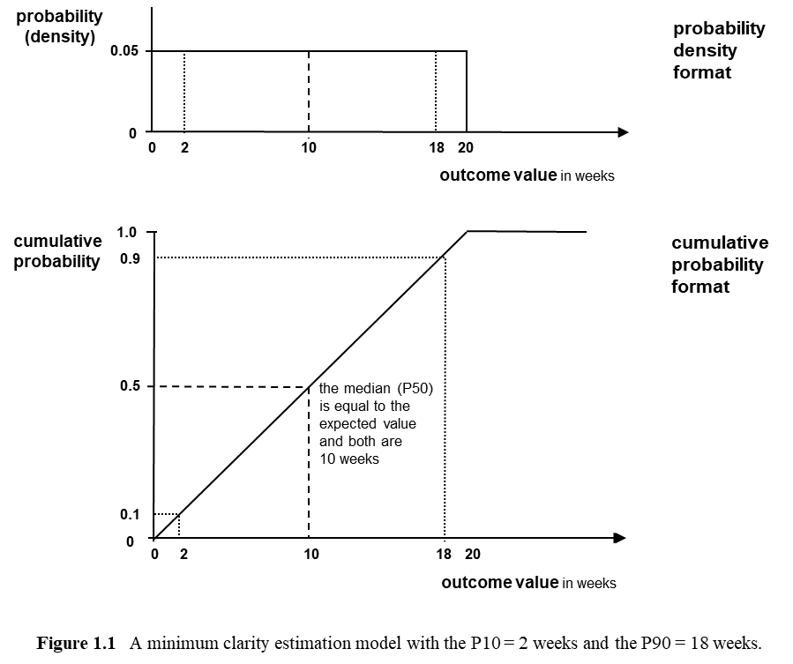

The uniform probability density function model employed by the minimum clarity estimation approach portrayed by Figure 1.1 was usefully associated with an underlying reality which might look like the dashed curve in Figure 1.2.

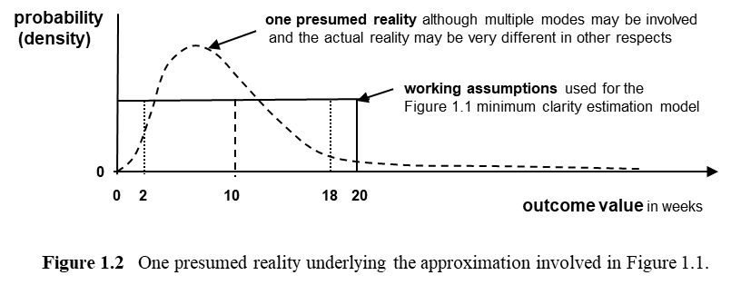

Recognising the uncertainty about the underlying reality is important characteristic feature of the systematic simplicity approach at all levels of clarity. We need to remain aware that what we are assuming to ‘keep it simple’ involves working assumptions – it does not involve an accurate portrayal of a reality we do not currently know much about and may not be able to fully understand.

This minimum clarity approach was the simplest available, by design. However, its design has been evolved and tested for robustness over many years with widespread use in mind, and:
- given its simplicity it is surprisingly rich in terms of useful information;
- its form provides the most flexible available starting point for adding clarity which might be useful if the effort/cost of doing so is worthwhile;
- it is demonstrably robust.

In terms of information content, the P10 = 2 weeks represented a useful default value for an aspirational target, and the P90 = 18 weeks represented a useful default value for a commitment target. Both of these targets can be given a wide range of interpretations, with no generally imposed restrictions, using different percentile values if this is deemed desirable so long as they are symmetrically spread about a 50 percentile value assumed to define a balanced target equated to the expected outcome. This meant that William’s team could use the P10 and P90 values plus the expected value of 10 weeks (assumed to be an appropriate balanced target) in the form of a simple range estimate stated as 10 +/- 8 weeks.

Specification of three separate targets in this simple minimum clarity form was very useful. The ABC of targets (aspirational, balanced and commitment target values) were a starting point for managing uncertainty which everyone involved in creating or using plans at all levels in all areas of an organisation ought to understand in the same way. William’s team could make base plans using the balanced target (expected value) duration of 10 weeks, contingency plans to exploit good luck if only 2 weeks was required, and further contingency plans to cope with bad luck if 18 weeks was required. Provided everyone involved understood this is what a range (interval) estimate of 10 +/- 8 weeks involved, this was a very rich and useful information set, obtained with very little effort, and expressed concisely for easy communication.

Adding more clarity

If more effort to provide greater clarity looked useful, William’s planning team could generalise the minimum clarity model of Figure 1.1 in a number of ways. They could do so within a working assumption that only one source of uncertainty was involved, or they could consider multiple underlying sources of uncertainty, explicitly decomposing different sources of uncertainty for various purposes – effective contingency planning for example.

Preserving the current assumption of ‘one source of uncertainty’, but relaxing the current ‘one scenario’ assumption, William’s team might use a set of data points from previous experience of design change approvals and basic textbook statistical techniques to construct the five scenario HAT (histogram and probability tree) model of Figure 1.3

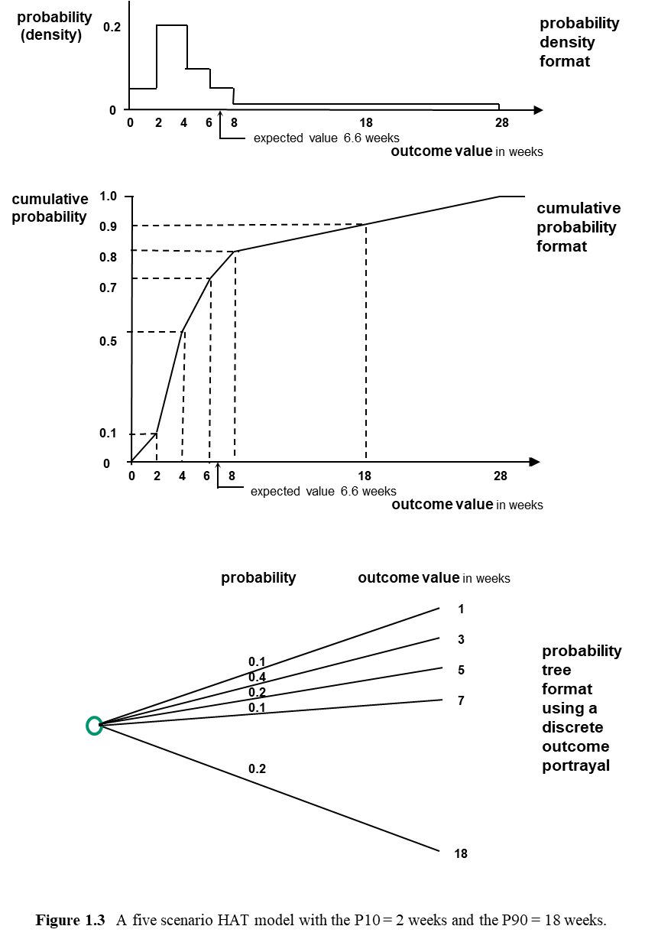

A multiple scenario probability tree portrayal, using five discrete outcomes in this case, underlies the rectangular histogram continuous variable probability density portrayal and the piecewise linear cumulative probability distribution portrayal of Figure 1.3. Using a HAT interpretation of Figure 1.3 initially focussed on the probability tree clearly implies that an expectation of 1 week is associated with the range 0-2 weeks with a probability of 0.1 on the top probability tree branch, an expectation of 3 weeks is associated with the range 2-4 weeks with a probability of 0.4 on a second probability tree branch, and so on. A multiple branch probability tree portrayal like the five branch portrayal of Figure 1.3 assumed to underlie a continuous variable rectangular histogram portrayal of the same information can be especially valuable as an operational framework for considering both statistical dependence and causal dependence, including addressing different contingency planning responses to particular outcome values. Embedding decision trees whenever contingency planning is relevant is crucial, but so is a flexible approach to associated causal dependence which needs to be decomposed and structured to be managed effectively, and statistical dependence which may not be well behaved but needs a degree of understanding. This operational framework also provides an important conceptual framework for thinking about uncertainty and its management even if we sometimes choose not to fully exploit it, comparable to having a general underlying theory to draw on when making simplifying assumptions.

This is an n scenario generalisation of the one scenario Figure 1.1 approach with n = 5, the unrestricted nature of this multiple scenario generalisation of the minimum clarify approach using the HAT framework being another defining characteristic which is a feature of a systematic simplicity approach.

All three of the portrayals used by Figure 1.3 can be useful, but using all three portrayals at the same time will not usually be necessary. Appropriate simplifications can and should be tailored to suit the context.

Planning teams obviously should make the best feasible use of readily available data if they have time to do so. But if William’s team were convinced that Figure 1.3 captured the available data and correctly portrayed a ‘normal outcome’ scenario with an expectation of about 4 weeks in the range 0-8 weeks and a probability of about 0.8, plus a ‘high outcome’ scenario with an expectation of about 18 weeks in the range 8-28 weeks with a probability of about 0.2, a much simpler two scenario model might be preferred for contingency planning purposes. This simplified approach might exploit the premise that a ‘normal outcome’ scenario of 4 weeks with associated modest variability over the range 0-8 weeks was not worth contingency planning effort, but a ‘high outcome’ scenario of 18 weeks with associated significant variability over the range 8-28 weeks did warrant attention.

Figure 1.4 portrays this two scenario interpretation, a simpler version of Figure 1.3 in terms of presentation as well as model structure. Figure 1.4 illustrates joint use of continuous variable and probability tree representations in a simple HAT presentation format showing the continuous variable density portrayal plus the discrete variable tree portrayal. It omits the cumulative probability distribution format portrayal to keep the portrayal format simple in a fairly obvious way.

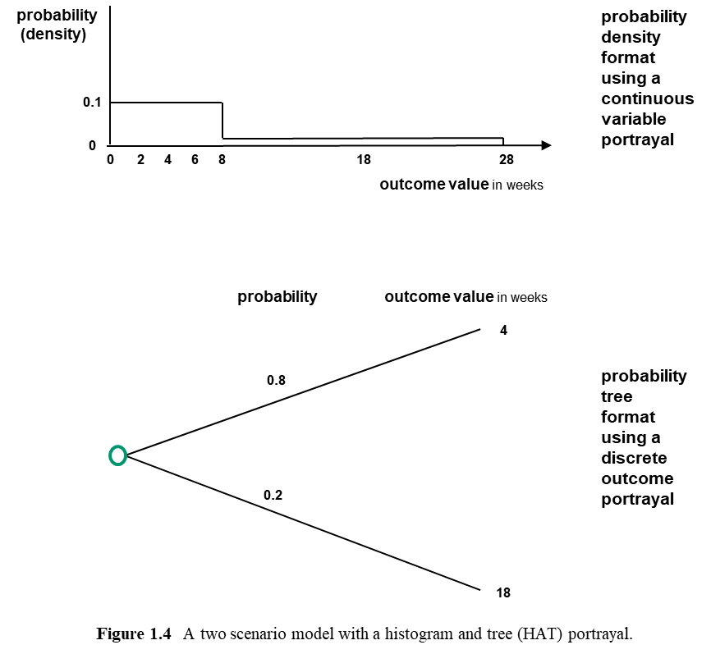

However, had no data been available, requiring a purely subjective estimate by William’s team, three scenarios might be the preferred portrayal for both estimation and contingency planning purposes. The grounds might be:
- most of the people involved thought Figure 1.1 was too simple to be credible for estimation purposes,
- Figure 1.3 was deemed more complex than necessary,
- three scenarios seemed to be the most comfortable and useful middle ground.

If William’s team wanted to make use of three scenarios, they might choose to employ a format like Figure 1.5. The Figure 1.5 example maintains consistency with the illustrative Figure 1.1 to 1.4 examples, with a P90 estimate of 18 weeks, a P10 of 2 weeks, and a two week common minimum class width interval. It was defined by also estimating a P80 of 8 weeks and a P20 of 4 weeks.

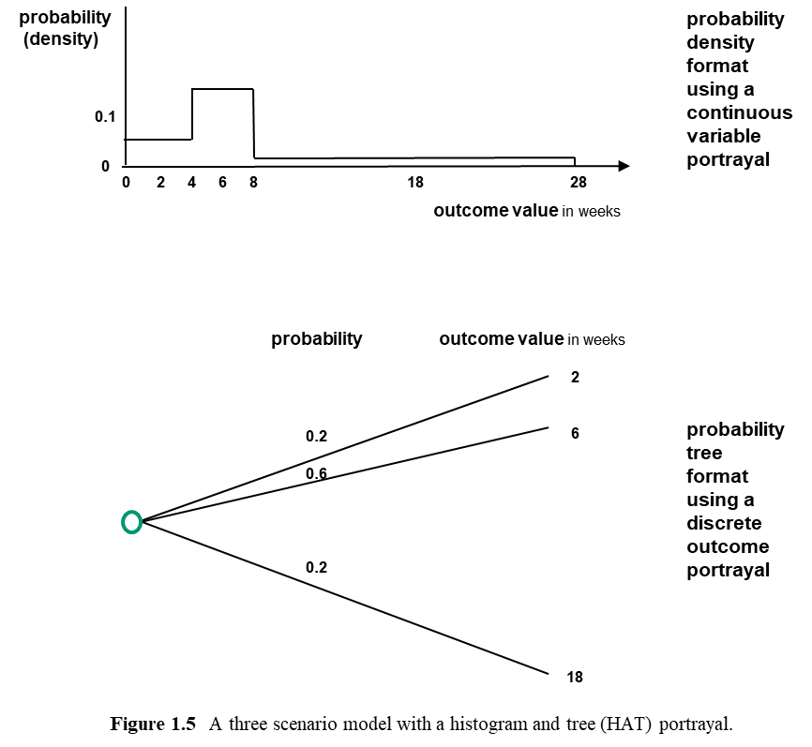

For comparison purposes, compatibility of Figure 1.5 with Figures 1.1 to 1.4 is useful in terms of an illustrative example. But in practice, William’s team would not need to worry about this kind of compatibility. Further, they might prefer using a classic three point Beta distribution specification involving a minimum, maximum and most likely value specification, as discussed by textbooks like Moder and Philips (1970) and used by many project planning teams since the 1960s. Parametric specifications of this kind can be accommodated within a HAT approach, as discussed in Enlightened Planning. But using a ‘plausible maximum’ like a P90 is usually important, and always avoiding direct estimation of an absolute maximum P100 value unless it is clearly defined by the circumstances is a best practice mantra if a systematic simplicity approach is adopted.

Building on this discussion of Figures 1.3 to 1.5, several further points are worth thinking about. First, if they had the data underlying Figures 1.3 and 1.4, this discussion of systematic simplicity approach options should get William’s team thinking that their data was limited, and their model omits important possibilities beyond the current data set. Second, if they did not have data, when they were thinking about a P90 they might have overlooked the possibility of extremes. For example, in either case, the possibility of a ‘very high outcome’ scenario with an expected value of 52 weeks (a year) and a probability of about 0.02 (a one in 50 chance) might be important. A ‘project cancelled’ scenario with a probability of about 0.01 might also be important. If they understood this, and how to address scenarios of this kind, they might begin to see why always starting with a basic minimum clarity estimate as a default position was sound policy. They might also start to see that enhancement of clarity was feasible in a very flexible set of ways. It should then become clear that how best to enhance clarity might not involve more refined looking curves and analysis restricted to data, even if reasonable data was available and most of the people involved had a strong current preference for smooth curves based on as much data as possible. They should also begin to see why this kind of approach to estimation earlier in a project lifecycle could be extremely valuable. If avoiding the need for expensive design change approvals or a project becoming completely redundant were important potential concerns, these issues might warrant significant early attention in terms of proactive preventative contingency planning, as part of building on a minimum clarity position with a clear agenda for more clarity that was worth the effort and a much better idea about what different kinds of effort might or might not be useful in this context. Precise answers to questions like ‘what is the probability of a very long delay?’ may not be important, but asking the right questions and then getting unbiased responses in a suitable timeframe for identifying and then making robust choices is always important.

In terms of robustness, if different people believed the presumed reality curve in Figure 1.2 was in different places, these differences of opinion would not actually matter provided those involved all believed that the expected outcome and range estimates agreed were reasonably unbiased and the base plan and contingency planning target values being used were appropriate. However, a very long right-hand tail associated with the presumed underlying reality would drag to the right both the expected value and an appropriate commitment target. Experience suggests that this ambiguous long-tailed distribution effect is one extremely good reason why the apparent simplicity of the minimum clarity estimation approach is actually a subtle basis for robustness which is surprisingly sophisticated.

When I used a HAT prototype approach with BP in the 1970s and 80s (as discussed later in this book), BP developed computer software with my support to work with estimate formats comparable to the five scenario format of Figure 1.3 with the person specifying the estimate choosing to use from 1 to 20 common interval class scenarios as the basic input format. This software could also accommodate Beta distribution specifications using P90 plausible maximums with longer right hand tails than a standard Beta distribution, plus other parametric probability distribution specifications. Monte Carlo simulation approaches embedded in widely available software packages can now perform the same operations with no restrictions on the number of scenarios or the nature of the scenario structure, and HAT approach users can now employ any suitable simulation software. However, you might like to bear in mind that in practice BP planners usually found that from 3 to 10 common interval class scenarios was the most convenient level of precision, sometimes preferring parametrically specified distributions (like a log Normal distribution or a Beta distribution hybrid with Normal distribution tails) converted into a HAT form for computation purposes. Sometimes 10 or more classes associated with scenarios or parametric specifications are useful, but in most client application areas since the 1980s my early preference for the simplicity of a one scenario approach like Figure 1.1 some of the time, a 2 to 10 scenario approach most of the time, and occasionally more classes or parametric specifications, has steady moved towards greater systematic simplicity. I now regard the minimum clarity Figure 1.1 approach as a practical first pass approach in many contexts, always assuming that later passes of a multiple pass approach will use more scenarios if the first pass analysis suggests this source of uncertainty needs more attention. An obvious exception is when those involved believe more scenarios are immediately useful and worthwhile. A Figure 1.1 based approach is a systematic simplicity recommended minimum clarity approach in this sense.

Clarity efficiency

A systematic simplicity approach often exploits a deep understanding of underlying complexity to justify the robustness of exceptionally simple tools for routine use. A prior investment in the development of this understanding is required, to ensure that the ‘right kind’ of simplicity is used and understood, avoiding the ‘wrong kind’ of simplicity.

Always minimising the overall effort/cost of decision making given the level of clarity required in any given context is the central concern. One useful way to visualise the discussion with William about Figures 1.1 to 1.5 is to consider the concept of ‘clarity efficiency’, where ‘clarity’ means relevant insight that can be communicated effectively to everyone who needs to understand. ‘Clarity efficiency’ is achieved when any given level of clarity is achieved with a minimum level of effort/cost. Clarity efficiency for all levels of clarity which may be feasible can be associated with an ‘efficient frontier’ as portrayed by Figure 1.6.

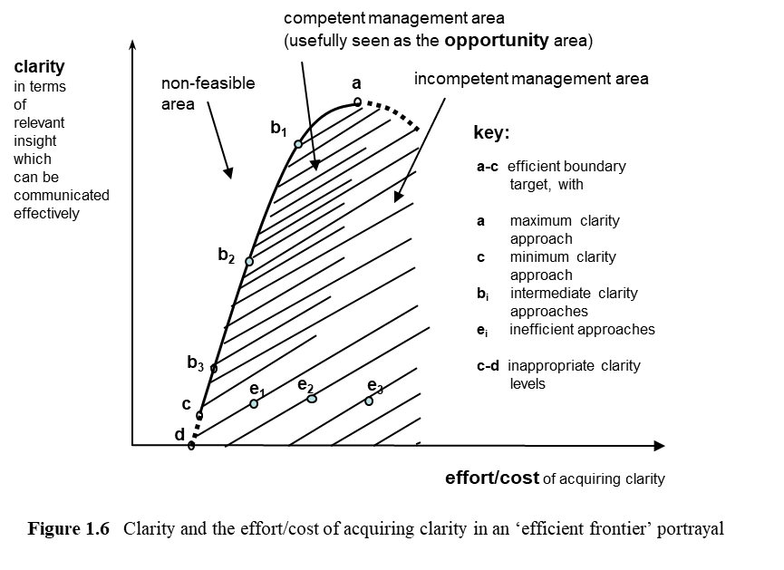

Any point on the clarity efficient frontier from point ‘a’ to point ‘d’ maximises the level of the clarity provided for any given level of effort/cost associated with acquiring that level of clarity. Point ‘c’ on Figure 1.6 corresponds to the minimum clarity estimate 10 +/- 8 weeks portrayed by Figure 1.1. The follow-on discussion associated with Figures 1.2 to 1.5 corresponds to an initial exploration of how best to move from point ‘c’ towards point b₃ on the clarity efficient frontier defined by the boundary from ‘c’ to ‘a’.

Any organisation routinely using a probabilistic approach to estimation which does not distinguish low effort first pass approaches from higher effort later pass approaches is arguably failing to manage the opportunity to use less effort to get the clarity needed, potentially operating at points like e₁, e₂ or e₃ instead of a point on the clarity efficient boundary between points ‘c’ and b₃ on Figure 1.6.

Any organisation using a single value ‘point’ estimate without clearly indicating its nature is seriously clarity inefficient – probably operating at a point well below point e₃ on Figure 1.6, using more effort than necessary to get much less clarity than needed. A surprising number of organisations habitually persist in working with point estimate approaches that are seriously clarity inefficient. They could simultaneously significantly increase clarity and use much less effort if they adopted a systematic simplicity approach involving range estimates like 10 +/- 8 weeks as a starting point in a suitable iterative process, a useful opportunity to use less effort and make better informed decisions.

The region close to the clarity efficient boundary is the competent management area in the sense that best practice ought to aim to be on the clarity efficient boundary, and while getting reasonably close to the boundary requires competence, failing to get reasonably close is incompetent. The exact location of the boundary between competence and incompetence is clearly ambiguous and debatable, but the existence of a boundary is not.

A useful way to view the competent management area is as an opportunity area in the sense that the approach to opportunity management advocated by this book is about trying to always work in this region, seeking the best point on the clarity efficient boundary. Working in this opportunity area is the clarity efficiency aspect of the overall opportunity efficiency we need to seek, including looking for the optimal trade-off point on the efficient frontier boundary.

Where a planning team should aim to be on the clarity efficient boundary, and how they should proceed to get there, is always highly context dependent, and competence in terms of systematic simplicity approaches is required to make associated judgements. However, if a number of estimates are required as part of any planning analysis, it is generally useful to use an iterative approach to seeking overall clarity efficiency at an appropriate overall level of clarity, starting with clarity efficient estimates at a low level of clarity for all the values of interest. This can include using minimum clarity estimates as a default starting position choice. It should always include adding clarity in an efficient manner to those estimates which seem particularly important.

Starting with a P90 estimate followed by a P10 estimate embracing all relevant uncertainty as the basis of an expected value estimate is a useful first step towards controlling unconscious bias. But much more can and should be done about unconscious bias in a clarity efficient manner if this seems appropriate. Recognising and addressing unconscious bias as approached by authors like Kahneman (2012) can be extremely important.

Conscious bias can also be addressed if relevant, as part of a package of ways of adding clarity and reducing bias. The Air Vice Marshal mentioned earlier in this chapter introduced me to the concept of ‘a conspiracy of optimism’, a very useful concept embracing conscious and unconscious bias, and a euphemism which I prefer to ‘strategic misrepresentation’ (Flyvbjerg et al, 2003). ‘Strategic misrepresentation’ is one version of ‘being economical with the truth’ which is widely cited in the literature.

All variants of both conscious and unconscious bias need attention in a clarity efficient manner. Enlightened Planning provides a starting point for engaging with a very extensive literature.

Expected penalty cost interpretation of balanced target values

Sometimes an ‘expected penalty cost’ approach to a balanced target using a ‘penalty cost function’ can be useful for immediate operational reasons, and this option is always useful in the background for conceptual purposes, playing a role comparable to ‘useful theory’.

As an illustrative initial example, say we want to move from a personal context estimate like ‘it will take me about 90 +/- 30 minutes to travel from my office to the airport check-in desk for a flight that I have to catch to get to a moderately important but routine business meeting’ to answering the question ‘how long before I need to be there should I leave?’ In this context an expected penalty cost approach lets us weight the ‘penalty costs’ associated with being early or being late to various degrees using a penalty cost function to weight the amount of time involved. This penalty cost function can reflect the importance of what we think needs doing before we leave, what we can do while waiting at the airport, if we miss our booked flight whether there are further flights later that day which we might get on, the level of importance of the meeting, and so on. At its simplest, being 15 minutes too late has a much higher penalty cost than being 15 minutes early. If B₁ is defined as our basic starting point balanced target time to the airport equal to the expected outcome, it will incorporate a ‘provision’ for extra time needed on average over and above the aspirational minimum. If B₂ is defined as our balanced target time to the airport incorporating this provision plus an additional ‘contingency’ of further time not needed on average but useful because being late involves a higher penalty than being early, this higher value incorporating ‘provision plus contingency’ might be preferred. It could be obtained by weighting possible outcomes by the relevant penalty costs before applying the probability of each outcome to get a weighted expected penalty cost value, with a view to minimising the expected penalty cost value when choosing the time to leave for the airport. This expected penalty cost approach simply involves recognising that all departures from the mean are not equally unwelcome. The weights used will often have to be fairly crude highly subjective measures of annoyance and anxiety which cannot be assessed with precision. However, imprecise but unbiased weights will do a much better job than no penalty cost weights at all. Equal weights for all outcomes are implicit in using expected outcomes, B₁ instead of B₂. It may be clarity efficient to explicitly use B₂ instead of B₁ with a clear understanding of its meaning and the approximation involved, avoiding bias as far as possible.

One relatively straightforward corporate decision making example of using a B₂ in this way is setting budgets for projects based on a B₂ estimate. As an illustration, when BP International decided at board level to adopt a prototype systematic simplicity approach to all sensitive or sizable projects on a worldwide basis in the late 1970s, they also mandated using a P80 value to set associated budgets in terms of the measured uncertainty. The BP board appreciated this was not a ‘commitment target’ in the P90 sense discussed earlier, and not all relevant uncertainty had been measured. They were using a B₂ value balanced target considering the trade-offs between not giving project managers enough contingency (extra money above the expected cost as measured) and giving them too much contingency, addressing all the governance cost and incentive implications, bearing in mind not all components of uncertainty had been measured.

In some contexts, the same ‘expected penalty cost’ approach can help us to understand how to respond to people using and perhaps insisting on single value estimates plus the implications of insisting on or simply accepting single value estimates ourselves.

For example, a senior colleague you know very well might ask how long it will take you to deliver a project. You might know that he or she wants a single number that they can use with confidence to discuss delivering what others will subsequently expect. In this case you might use a B₂ value balanced target which reflects the pain both of you will feel if you fail to deliver, as well as the rewards of exceeding expectations. You might do so explicitly assuming you have a mutually understood and shared penalty cost function, everyone else involved will understand that you both normally deliver what you say you will deliver in a way which usually exceeds expectations, and you do not need to demonstrate why this is the case on this occasion.

However, if there is a risk of serious problems if everybody involved does not have the same understanding of what a single value means, the results can be painful for everybody. For example, if a senior colleague insists on a lower number for the duration of a project that you have to deliver than you are comfortable with in terms of your own personal B₂ balanced target value, you may be risking your reputation by agreeing, or perhaps even in effect committing yourself to looking for another job just before this project all goes horribly wrong. If those being reported to fail to understand this kind of situation, they may blame you when it goes wrong, your senior colleague, or both of you. Arguably they may also have themselves to blame at least in part for failing to anticipate the muddle which a point estimate approach can create.

What you can infer from these examples is in addition to an expected penalty cost approach to a balanced target using a penalty cost function being operationally useful in a direct way if it is used appropriately, it is also a useful way to view the implications of organisations using single value estimates inappropriately. Sometimes it may be useful to interpret other peoples’ suspected ‘strategic misrepresentation’ in the Flyvbjerg et al (2003) sense as being driven at least in part by their use of an expected penalty cost approach, implicitly if not explicitly. However, it is important not to confuse the rationale and function of the weights used appropriately in a penalty cost approach with an inappropriate conscious or unconscious bias, with a wide range of possible explanations and associated treatment strategies.

By the end of Part 1 of this book, most readers should be reasonably comfortable with their understanding of uncertainty in terms of B₁ and B₂ balanced targets, how both provide useful information which is quite different to aspirational target values and commitment target values, and why it can be very helpful to understand the roles of all four of these values in some particularly important decision making contexts.

This expected penalty cost approach provides a useful basis for understanding some aspects of ‘risk’, but it does not address risk in the risk efficiency sense. By the conclusion of Part 1 all readers should understand why the concept of ‘risk’ often needs much more sophisticated treatment than a simple penalty cost approach.

Concluding observations

This chapter has briefly explored the use of a very simple minimum clarity approach to estimation, addressing a basic metric for an attribute of interest like the duration of a project activity. It has also used this discussion to provide an initial exploration of the clarity efficiency concept.

The focus of this book is decision making and associated planning by organisations, but most of the systematic simplicity ideas discussed have implications for personal decisions as well. The estimation of parameters is a good illustration of why this is the case.

This chapter’s discussion was set within a HAT framework, considering a single source of uncertainty. It explores the generalisation of a basic single scenario portrayal to a multiple scenario portrayal. Later chapters will retain a HAT framework but consider more than one source of uncertainty as the basis of a route to more clarity. This will begin to illustrate the value of developing an understanding of a number of different ways to visualise the decomposition of ‘uncertainty’.

One basic form of decomposition involves distinguishing five portrayals of uncertainty as indicated in the ‘Preface and introduction’ section:
- variability uncertainty,
- event uncertainty,
- ambiguity uncertainty,
- capability-culture uncertainty,
- systemic uncertainty.

The distinction between the first two may involve important inherent differences or just preferred portrayal options. The third involves a lack of knowledge which may be partially resolvable. The fourth involves the capabilities of systems which include computers prone to malfunction plus people prone to human errors and cultural influences which may be positive or negative. The fifth involves interdependencies which may be simple or very complex.

The complexities associated with systemic uncertainty start to become obvious as soon as we decompose estimates into component sources of uncertainty, the focus of Chapter 3. But they extend beyond the overall estimates used to make decisions. They are also inherent in the processes we use to try to ask the right questions and interpret the answers to act in the right way, and all the associated underlying ‘deciding how to decide’ choices we make. In this very general sense, they are central to the whole of this book.

Even when employing a minimum clarity estimate using the Figure 1.1 model, it is worth understanding that a very broad view of uncertainty needs to be taken in many contexts. This implies the Figure 1.2 portrayal of underlying uncertainty may not be straightforward to visualise. It is part of the reason that a minimum clarity approach is much more sophisticated than it looks. It is also part of the reason why using a P50 defined by a Figure 1.1 approach as an expected value ‘balanced target’ is much less pessimistic than it may seem. Many people’s first reaction to the suggestion they should use a Figure 1.1 model is ‘it is far too pessimistic, and a simple asymmetric model like a Beta distribution is much better’. But the Figure 1.1 model can actually prove far too optimistic. If the reality is a long right-hand tail as Figure 1.2 suggests may be the case, the actual outcome may be a much longer duration than any deemed feasible by a Beta distribution with a P100 plausible maximum as assumed by standard PERT model analysis.

As illustrated with examples later in this book, a systematic simplicity approach generalises key ideas underlying the minimum clarity estimation perspective. It argues that decision making and associated communication is greatly enhanced if everyone involved develops a reasonably well-grounded intuitive understanding of the idea that making simplifying assumptions effectively always requires some of those involved knowing what very high clarity assumptions to capture requisite complexity can achieve in a reasonably wide variety of example contexts. In some contexts, those providing this expertise may be involved directly. In other contexts, they may be involved indirectly, perhaps by designing processes for others to use as discussed in Part 2. But somebody has to judge which particular aspects of complexity may or may not matter in any given context, even if the contexts currently being addressed are relatively simple.

Those who design the planning and decision making processes an organisation uses or lead one-off analysis have to understand the implications of alternatives, and everybody else has to trust their judgement if they do not fully understand the rationale. Well-founded trust within an organisation involves everyone trusting their expert advisors in this sense, and experts who cannot be trusted in this sense are a liability needing effective senior management attention, ultimately a board level responsibility. This applies to very simple contexts like estimating parameters, as well as the much more complex contexts we need to move on to now.

Chapter 2 A simple opportunity efficient approach to seeking risk efficiency

The risk efficiency, clarity efficiency and opportunity efficiency trio

A central aspect of effective decision making is being able to identify and then choose between alternative courses of action to increase expected reward, reduce associated risk, and provide appropriate trade-offs. ‘Reward’ may need to be addressed in terms of component positive performance attributes like profit, net of component negative performance attributes like cost. Risk-reward trade-offs for any given performance attribute are involved and may need attention, and trade-offs between different performance attributes may also need attention.

One of the core concepts involved is ‘risk efficiency’. A ‘risk efficient’ choice provides a minimum level of risk for any given level of expected outcome in terms of any given attribute of interest. For each attribute of interest, expected outcome and associated risk are two different but interdependent performance criteria which a systematic simplicity approach treats as separate objectives. In the context of a risk efficient choice, ‘risk’ means the possibility of a ‘reward’ (positive) objective outcome which is less than that expected, or the possibility of a ‘cost’ (negative) objective outcome which is greater than that expected, a very general interpretation of ‘risk’ which is consistent with plain English.

Figure 2.1 portrays expected reward and associated risk in terms of an ‘efficient frontier’ diagram portrayal, a conceptual tool central to a systematic simplicity perspective.

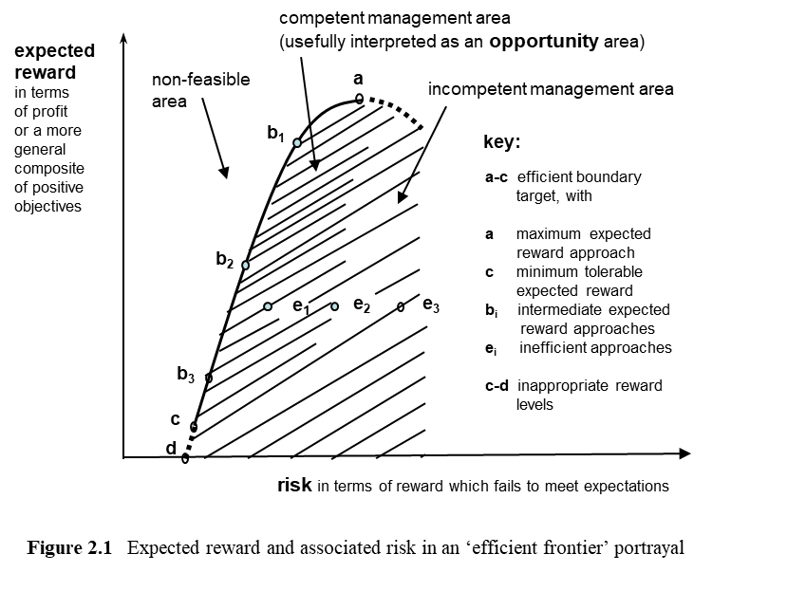

A diagram comparable to Figure 2.1 was made famous by Harry Markowitz in the 1950s when he developed the foundations of portfolio theory, leading to his 1990 Nobel Prize for Economics, and efficient frontier diagrams for any pair of objectives considered jointly have long been a common practice tool for economics. See Portfolio Selection: Efficient Diversification of Investments (Markowitz, 1959) for a classic basic reference.

The clarity efficient frontier diagram of Figure 1.6 employs a similar layout to Figure 2.1 because these two efficiency concepts are comparable and complementary. In both cases we need to seek a point on the efficient frontier boundary with an appropriate trade-off depicted by the slope of the boundary curve at that point. And we should be seeking clarity efficiency and risk efficiency at the same time within a holistic process framework which embraces both, so employing similar layouts to portray both efficient frontier concepts is useful.

The region close to the risk efficient boundary is the competent management region in the sense that best practice ought to aim to be on the risk efficient boundary, and while getting reasonably close to the boundary requires competence, failing to get reasonably close is incompetent. The precise location of the boundary between competence and incompetence is clearly debatable, but the existence of a boundary is not. This is directly comparable to the Figure 1.6 situation.

A useful way to view the competent management region is as an opportunity area in the sense that opportunity management as advocated by this book is about trying to always work in this region, seeking the best point on the risk efficient boundary, again directly comparable to the situation in Figure 1.6. Working in this opportunity area is the risk efficiency aspect of the overall opportunity efficiency we need to seek, including looking for the optimal trade-off point on the risk efficient frontier boundary in a manner which is clarity efficient.

Choosing point ‘a’ in Figure 2.1 involves ignoring risk and simply maximising expected reward. In many decision making contexts this may be a preferred and optimal choice, assuming that the risk involved is both bearable and acceptable, because it is clarity efficient. However, in a portfolio of securities context choosing point ‘a’ involves ‘putting all your eggs in one basket’, choosing the one security with the highest expected rate of return. This is not usually considered an optimal portfolio management strategy for a portfolio of securities, the context of direct interest to Markowitz. In a portfolio of securities context, it is usually important to consider taking advantage of the possibility of significantly reducing risk with a minimal loss of expected return by moving towards point b₁. This movement towards point b₁ involves efficient diversification, reducing the level of risk with the minimum loss of expected return to preserve risk efficiency. Points b₂, b₃ and ‘c’ involve further risk efficient reductions in the level of risk via efficient diversification, with point ‘c’ associated with the minimum tolerable expected reward.

When Markowitz developed the foundations of portfolio theory using this framework, he assumed that the expected reward on a portfolio of securities could be measured as a linear function of the expected return on individual security rates of return, and a suitable surrogate for risk could be measured as a quadratic function of associated variances and covariances. This book and all of my published work since the mid-1970s assumes that this risk efficiency concept needs generalising beyond a mean-variance approach and beyond a portfolio selection context, to provide part of the basic framework for all decision making. This chapter starts to explain the implications. Although most of this book is more directly concerned with choices between two or three discrete alternative options, sometimes it uses this kind of analysis in a pairwise nested manner to address whole portfolios, for corporate strategic planning purposes for example. Portfolio theory in general terms can address any number of options using any or no subset structures. Part 1 of this book ‘keeps it simple’ by restricting the focus to choices between two or three options in a project management context.

The focus of a basic Markowitz ‘risk efficiency’ approach is using quadratic programming to address a single measurable attribute like profit with a view to achieving the highest feasible level of expected reward for any given level of risk measured by variance, understanding the available trade-offs between expected reward and risk given risk efficiency in this sense, and choosing the maximum level of risk which the decision makers believe is prudent. The focus of the basic systematic simplicity generalisation of risk efficiency is providing a range of low to moderate effort approaches to delivering risk efficiency even if only two discrete option choices are available, and doing so in an effective manner without making any of the restrictive assumptions about the measurement of ‘risk’ employed by a mean-variance approach, recognising that more than one attribute often needs attention.

Opportunity efficiency builds on underlying risk efficiency and clarity efficiency – it is a higher order composite concept. Opportunity efficiency involves ensuring appropriate trade-offs between expected outcomes and associated risk for all relevant attributes given risk efficiency, plus ensuring appropriate trade-offs between all relevant attributes. This includes the trade-offs between clarity and the effort/cost of acquiring that clarity, bearing in mind the complex multiple attribute nature of ‘clarity’ and the ‘effort/cost’ of clarity plus the consequences of insufficient clarity in terms of all relevant attributes.

A simple illustrative example

To initiate discussion of an opportunity efficient approach to risk efficiency, assume that in choosing between alternative decision options only one attribute is of immediate interest, and this attribute is a directly measurable cost. Further, assume that we want to use minimum clarity estimates as discussed in Chapter 1 to choose between the decision options. In this situation a simple low effort decision diagram which uses linear cumulative probability distributions as illustrated by Figure 2.2 can be a valuable tool. Figure 2.2 portrays three decision options with different expected costs and associated cost uncertainty. Consider how such a diagram might be used in a real situation which is very simple for illustrative convenience.

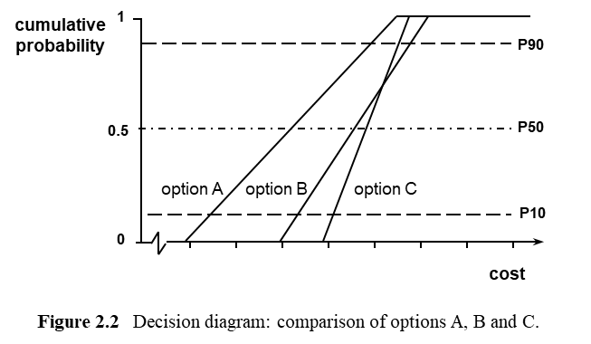

In the mid-1980s, as a newly appointed head of a university academic department, replacing my department’s photocopier was one of the first departmental decisions to be made. The need for simple decision diagrams using the format of Figure 2.2 arose at about the same time, and ‘the photocopier problem’ seemed a useful story to illustrate the low effort and moderate clarity linear decision diagram concept. The intention from the outset was employing this story as a very simple way of communicating an approach which is actually applicable in a very wide variety of much more complex contexts – like the IBM UK illustrations discussed later.

The story begins when my department’s only photocopier failed terminally. The service engineer delivering the bad news explained that a new photocopier with appropriate features from his firm would involve a new five year contract with a rental cost of £x per month plus a servicing charge of £y per copy. The new photocopier could probably be delivered within a few days.

Some idea of the department’s likely level of photocopying was clearly needed. The departmental secretary provided records showing copy numbers by months for recent years. This historical record was projected forward for five years, as the basis for an approximate P10 to P90 range estimate for a nominal five year planning horizon defined by the contract duration. The Figure 2.2 axes were constructed, with the cost scale indicating total cost over the five year contract period. Contract cost was assumed to be the only attribute of concern as an initial working assumption. The P10 and P90 values were then used along with the service engineer’s £x per month and £y per copy contract explanation to obtain the ‘option A’ linear cumulative probability curve shown in Figure 2.2. Telephoning two alternative photocopier suppliers revealed identical contract structures for photocopiers with comparable features. But the alternative suppliers had higher £x rates and lower £y rates. These rates were used to plot the ‘option B’ and ‘option C’ lines in Figure 2.2.

Figure 2.2 suggested option A was the only risk efficient choice, by a significant margin, given the assumptions used to produce it. This was clearly illustrated in terms of what the technical literature calls ‘stochastic dominance’, because the line portraying option A was well to the left of the lines for options B and C. That is, the expected cost of option A was much lower than the expected cost of options B and C, and the probability of options B or C costing more than the expected cost of option A was clearly much greater than the probability of option A costing more than the expected cost of A at all probability levels. Although the cost of option A was more variable than the cost of options B or C, option A was not riskier, because of the significant expected cost advantage of option A. In conventional ‘stochastic dominance’ terms, option A dominated options B and C. In systematic simplicity terms, Option A was the only risk efficient option given these three choices and the other working assumptions.

In terms of Figure 2.1, if option A was associated with the risk efficient point b₂, options B and C might be associated with risk inefficient points in the region of e₁ and e₂.

Continuing to assume that cost as currently measured was the only attribute of interest for the moment, and looking back to the Figure 1.2 presumed reality underlying the working assumption for Figure 1.1, the uniform probability density function and associated linear cumulative distribution seemed a reassuringly robust assumption given the size of the gap between the option A line and the lines for the other two options. Formally checking that this was the case was a very basic robustness test, and it was important to be aware of the need to make this kind of robustness test. It involved asking the question ‘could plausible assumed alternative realities underlying the measurement of contract cost as portrayed by Figure 2.2 make options B or C preferable?’ The size of the gap between the option A line and the option B and C lines suggested this aspect of the analysis was reasonably robust.

Testing the robustness of the analysis in terms of further attributes which might be relevant was arguably even more important than testing the robustness of the linearity assumptions associated with the measured attribute, and doing so raised very different kinds of issues. Some of these issues were reasonably straightforward to deal with, but others required much more care and attention. In general, a systematic simplicity approach to all comparable decisions requires a ‘clarified dominance’ generalisation of the conventional ‘stochastic dominance’ concept which deals with all the further potential attributes that might matter and all related issues that might matter.

The premise that copying speed might matter was tested next. This robustness test began by asking ‘was the copying speed of option A faster than that of options B and C?’ Assuming copying speed is measurable simply by consulting supplier specifications, checking the specifications of all three photocopier options confirmed that option A was faster than options B and C – so option A dominated on this criterion too. No further effort was required in terms of the initial working assumption that copying speed did not matter. Had option A been significantly slower than options B or C, the cost of the additional time lost by people waiting for copies might have been estimated in opportunity cost terms. But a simple ‘was the contract cost difference worth the speed difference?’ question and answer might have sufficed, depending on the figures involved and the perceived importance of copying speed relative to the importance of cost.

The third robustness test began by asking ‘was there any evidence that options B or C might be more reliable than option A?’ There was no evidence about B or C, but the departmental secretary assured me that the old photocopier had been very reliable for many years before its terminal failure, so option A seemed to dominate on the reliability attribute in terms of readily available data with no significant incentive to seek more data, and no obvious need to think about reliability-cost trade-offs in opportunity or shadow cost terms.

The fourth robustness test began by asking ‘was the departmental secretary happy with the anticipated noise level of the option A photocopier, and any other relevant features or aspects, including its colour and style, given it would be in the departmental office which was her office?’ Enquiring about the noise level, colour, style and any other relevant features of the options and involving the departmental secretary in the choice was an obvious matter of courtesy. It suits the flow of the story to introduce these issues now, but in fact this would have been the best place to start, including asking her at the outset if there were any issues other than those considered above which she thought ought to be explored. She was better placed to see some relevant forthcoming technology and organisational changes than I was. She was also the most directly interested party, and her views were crucial. If colour or style or noise or some combination of these issues mattered, Figure 2.2 was still relevant, but the attributes and associated objectives of interest to the departmental secretary would need very careful explicit attention, and if they were important enough, they might prove the dominant concerns in shadow cost terms. She liked the option A features on all counts, so it remained the obvious choice, without the need to make extensive comparisons with options B and C.

The fifth robustness test began by asking ‘could the supplier of option A actually deliver a new photocopier in a few days?’ If several months might be involved, making the use of option A non-feasible, the choice might move to options B or C.

This raised new issues. Options B and C were both risk efficient in terms of the contract cost attribute assuming option A was not available – but option B involved a lower expected outcome cost than C in conjunction with a higher level of risk, indicated by the lines crossing above the expected values. This was associated with option B having a lower £x rate than option C but a higher £y rate, so the expected outcome was lower but the outcome was more variable, and this time the linear cumulative probability distribution curves crossed, implying that option B could cost more than option C.

However, in practice the relatively small additional cost ‘risk’ associated with option B relative to C was just ‘noise’ – it was not worth worrying about. It was bearable risk and acceptable risk, in the sense that my department’s financial viability was not threatened by taking this risk and taking it was worthwhile if expected cost could be lowered as a consequence. Because this level of cost risk was just noise which could be ignored, it made sense to go for the lowest expected cost, and choose option B if option A was not available. More generally, it might be very important to use Figure 2.2 or a variant directly relevant to a context of interest to explain why ‘risk’ should be ignored, to make decision making both simpler and more effective simultaneously, an improvement in terms of both clarity efficiency and risk efficiency.

Changing photocopier supplier also raised a further new concern. The supplier of option B did not have an established reliability track record with my department, so reliability would now require recognition as a potentially important issue. This in turn clarified the fact that a valuable new option required identification – the option A supplier making an interim machine available until the ordered one could be delivered.

In general, we are always free to think about new options if the current set of options seems unsatisfactory for any reason, an important fall-back contingency planning option to always keep in mind.

It may help you to remember this if you always include a residual ‘any other options we have not yet considered’ possibility.

Concluding reflections

One key point this story should make clear is that Figure 2.2 is a simple but effective decision diagram portrayal of risk efficiency in terms of one ‘primary’ attribute, defining the primary attribute in this case as contract cost because that is the attribute which is the initial focus of interest. But the role of this decision diagram is very much richer than the portrayal of risk efficiency in terms of a single attribute. It is a moderate clarity portrayal of option choice implications which also facilitates testing for robustness in terms of all further attributes which may be relevant, and trade-offs involving relevant additional attributes can be considered in a manner involving modest effort that is reasonably effective even if some of the relevant attributes are not worth measuring or not amenable to measuring. Figure 2.2 provides all the clarity needed in this relatively simple context, and it demonstrates clarity efficiency at an appropriate clarity versus effort/cost of clarity trade-off position in a way which can be adapted for different contexts which might be much more complex.

A linked point worth noting here is if you are used to using the low effort decision diagram approach of Figure 2.2 and visualising range estimates associated with P50 expected values and a minimum clarity uniform probability density function model, you may not even need to draw Figure 2.2 equivalents to visualise the expected cost and cost risk trade-offs involved, just using spreadsheet equivalents. Enlightened Planning chapter 6 explores an illustrative example based on work with IBM UK in detail if you want to pursue this later.

Another related general issue of crucial importance, which this story and Figure 2.2 should clarify directly, is if risk is just noise for some attributes, in the sense that it is both bearable and acceptable when taking risk facilitates improving expected outcomes, then just using expected values is a very important shortcut within the risk efficiency framework adopted by a systematic simplicity approach whatever the approach used to estimate expected values. A particularly important special case involves ignoring risk, sometimes just using deterministic models based on unbiased expected values for parameters, but always acknowledging the potential importance of uncertainty. Knowing that this is the case in advance improves clarity efficiency, because it facilitates a very valuable opportunity to achieve more insight for less effort/cost. In the right circumstances ignoring risk can be opportunity efficient because it is both risk efficient and clarity efficient.

A further learning point is that variability and risk should never be confused – option A involves significantly greater contract cost variability than B or C, but much less risk. This is clearly demonstrated in Figure 2.2 by the different slopes but the large gap between the lines for options A and B or C, because the low £x rate for option A which takes the option A line significantly to the left of the B and C lines more than neutralises the cost variability driven by the higher £y rate for option A. This addresses a complication with Markowitz’s mean-variance approach to risk efficiency which he clearly understood but many people using his approach do not. Variance is never an appropriate direct measure of risk. Variance is only an appropriate surrogate measure of risk given a particular assumed expected outcome and given probability distributions with the same shape can be assumed. Uncertainty addressed using the stochastic dominance approach employed within the decision diagram framework of Figure 2.2 can include all relevant uncertainty without restrictive assumptions.

A set of related general points made earlier are worth additional more focussed emphasis here. Potentially important secondary attributes like photocopier speed which are easily measurable if relevant may require trade-off consideration. Secondary attributes like reliability, which is more difficult to measure may not be worth measuring, but consideration of the issues raised may still be needed. Inherently non-measurable issues, like the implications of the photocopier’s colour or style, may also prove important. These kinds of secondary attributes may need consideration in relation to a primary attribute like contract cost which can and should be measured, with questions like ‘if option B is the preferred choice in terms of a set of non-measurable or simply not measured advantages and disadvantages concisely expressed in verbal terms, is the contract cost difference between options A and B worth it?’ If the choice is a close call, this may suggest further effort and care to consider differences would be worthwhile. Most practical decision making contexts require the consideration of a primary attribute (like contract cost in this simple example) plus a number of secondary attributes. Sometimes the secondary attributes actually prove to be more important than what was initially identified as the primary attribute, and attributes not worth trying to measure or non-measurable may be crucial even if they are not the most important attributes.

Such considerations might reveal preferences not previously articulated. For example, as the decision maker in a variant of this example I might identify a shadow price/cost associated with insisting upon a photocopier with a slightly higher copy speed by constraining the option choice, and use an argument like ‘it will cost about £x per month more to have a photocopier which is y% faster, but bearing in mind staff convenience as well as the financial cost of their time, having undertaken consultation I think the extra cost is worthwhile’. If the trade-offs are important for some of the parties involved, and collaboration/trust issues matter, this kind of ‘revealed preference’ interpretation yielding an explicit shadow price/cost explanation of the trade-offs used to make choices may be useful.

In the 1990s, IBM UK made extensive use of variants of Figure 2.2 in a bidding case study used for a culture change programme and in the subsequent development of bidding processes as discussed briefly in Chapter 5 of this book, extensively in chapters 3 and 6 of Enlightened Planning. All of the learning points developed so far in this chapter were central to the IBM UK culture change programme and its Enlightened Planning discussion, including the use of a ‘traffic light’ system of blue to green to red lights to flag concerns that suggest strong positive or strong negative reasons for favouring or avoiding specific options which are not directly measurable, associated with the use of ‘smiles’ and ‘frowns’ tests. For example, in the context of bidding for a £20 million contract, option A might involve keeping a significant portion of the contract in-house while option B involved using a subcontractor. The in-house option A might attract a ‘frowns test’ red light if the in-house staff required are already seriously overstretched on another crucial contract, but a ‘smiles test’ blue light if they need the work and could provide non-price ‘quality’ advantages which the subcontractor could not provide and the potential customer would value, a neutral green light if no significant positive or negative issues of this kind were involved. The subcontractor option B might attract a blue light if they are a strategic partner needing explicit encouragement and support at this stage in a developing relationship, a red light if they are not a strategic partner and signs of unreliability are discernible, a neutral green light if no significant positive or negative issues of this kind were involved.

More generally, what is crucial is:
- starting with a simple low effort approach which can address more complexity whenever doing so looks worthwhile;
- comprehensive, effective and efficient assessment of robustness for the simple approach employed initially, testing all relevant simplifying working assumptions to decide whether or not more complexity to achieve more clarity is worthwhile;
- seeking more clarity of the kind that is needed when and where it is needed;
- a possible expansion of the option set, with creativity an essential capability;
- an ability to deal with additional attributes as well as the initially assumed primary attribute, sometimes using formal but simple mechanisms like ‘smiles tests’ and ‘frowns tests’, sometimes relying upon informally applied judgements of issues not given any formal analysis treatment.

The starting point for any particular analysis will always be context specific, and the operational toolset employed should be as simple and easy to use as possible, but the conceptual toolset drawn upon should be as general and flexible as possible, to facilitate systematically avoiding simplifying assumptions which are not robust.

Markowitz could use a version of the Figure 2.1 risk efficient frontier diagram as an operational tool, because he used variance as a directly measurable surrogate metric for risk. But variance is not a sufficiently general metric for risk for a systematic simplicity approach. The simple linear cumulative probability distribution approach employed by Figure 2.1 might suggest using variance as a metric, but the framing of the Figure 2.1 approach lends itself to asymmetric nonlinear generalisations discussed in Chapters 4 and 5. This means that the risk efficient frontier portrayed by Figure 2.1 is not an operational tool for systematic simplicity purposes. However, the risk efficient frontier concept is still a very useful conceptual tool.

Clarity efficiency was usefully portrayed using the efficient frontier diagram of Figure 1.6, but because ‘clarity’ and the associated ‘cost of clarity’ are both multiple attribute concerns which are not measurable in general, the clarity efficient frontier portrayed by Figure 1.6 is a conceptual tool without an operational variant in any framework.

Opportunity efficiency is also a conceptual tool of great importance. But opportunity efficiency cannot even be associated with an illustrative graphical tool like Figures 1.6 or 2.1 in a direct way, because it involves a complex set of trade-offs in more than two dimensions.

An underlying mathematical framework for opportunity efficiency can be exploited as a conceptual tool with operational tool implications in ways touched on later in this book, and some aspects of this underlying opportunity efficiency framework will have been intuitively obvious to some readers from the outset. In brief, for those who are interested now, it is based upon a goal programming approach – see for example a review paper by Tamiz, Jones and Romero (1998). Goal programming generalises the quadratic programming approach used by Markowitz to maximising one ‘primary’ objective with any number of relevant further objectives labelled ‘secondary’ objectives and visualised as constraints, initially set at assumed target levels of achievement. An initial optimal solution yields a set of shadow prices or costs defining the trade-offs between the primary objective and all secondary objectives at the optimal solution. An iterative process can then be used to converge to a solution involving an optimal set of trade-offs between all objectives. Expected attribute values and associated risk can be viewed as separate related objectives. The choice of a ‘primary’ objective is a matter of convenience, and some ‘secondary’ objectives may in practice be both more important than the ‘primary’ objective and not measurable. Part 3 of this book will further clarify what is involved, and Enlightened Planning will help you to take it further if you wish to.

This chapter used a particularly simple example to illustrate several quite general strategies for seeking clarity efficient approaches to multiple attribute analysis contexts which may be very complex. For example, one useful strategy involves starting by assuming that an analysis based on the expected outcome and associated risk of the attribute of primary interest may provide a solution which dominates in terms of all secondary attributes. If this is done, then testing the robustness of this assumption for each potentially relevant secondary attribute has to follow, ensuring that no attributes that matter are overlooked, even if they are difficult to measure or completely impossible to measure. More generally, when seeking opportunity efficiency a central concern is testing the robustness of a ‘clarified dominance hypothesis’ associated with a suitable set of decision diagrams and other supporting tools by repeatedly asking the question ‘is it worth trying to measure anything else before we consider making a decision, bearing in mind the costs and benefits of more measurement, and repeatedly asking the question “are there any further concerns which need qualitative attention”, whether or not they are measurable?’

If any potentially important further attribute is not measurable, the only choice may be to look at the difference in cost and ask ‘is the difference worth it?’ in consultation with all relevant parties, employing a consultation process that all relevant parties will respond to positively and trust. In these circumstances, collaboration/trust may be a crucial concern. If any potentially important further attribute is measurable, it can be important to assess whether or not doing so is worthwhile. We always need to make sensible judgements based on what has been measured and what has not been measured but might be important.

This book is about systematically simple quantitative analysis underpinned by appropriate systematically simple qualitative analysis, constraining the exploration of complexity to what pays. Most of the time we can keep it reasonably simple. However, there are occasions when considerable complexity must be confronted, including two or more attributes which both really matter. For example, in a safety context one key attribute is lives which might be lost, a second is life-changing injuries which might be sustained, and a third is cost concerns associated with reducing the risk of both lost lives and injuries.

Further, from a systematic simplicity perspective it is very important to appreciate that whatever the level of sophistication of the quantitative and qualitative analysis being used, there are important limitations on both what can be measured in quantitative analysis terms and what can even be considered in purely qualitative terms in a systematic formal manner.

The primary reason for raising these issues now is to explicitly and emphatically avoid the impression that systematic simplicity means quantification is essential or central or even universally feasible. Often quantification is not worthwhile if an effective qualitative analysis is convincing. Frequently further quantification is not worthwhile if effective partial quantification plus appropriate further qualitative analysis is convincing. Crucially, whatever the level of formal quantitative analysis, management decision making almost always also needs further qualitative analysis plus sound well-grounded intuition and informal planning, and it needs to employ creative thinking throughout.

The role of opportunity efficiency is of central importance in terms of any viable definition of what ‘best practice’ ought to be. In addition to the crucial underlying roles of risk efficiency and clarity efficiency, appropriate trade-offs between multiple attributes and between expected values and associated risk for any relevant attributes must be sought in an effective manner for best practice to be achieved.

Chapter 3 High clarity decomposition of sources of uncertainty for contingency planning

Decomposing uncertainty into multiple sources

The single source of uncertainty assumptions associated with the attribute assumed to be the primary or initial concern in Chapters 1 and 2 was a convenient simplification. However, there may be multiple reasons for assuming that decomposing uncertainty into more than one ‘source of uncertainty’ would provide useful additional clarity in relation to any given attribute of interest. Exploring the clarity efficient boundary of Figure 1.6 in the b₂ to b₁ region needs attention now, decomposing uncertainty into multiple sources to examine the high clarity end of the low to high clarity spectrum.

This chapter explores decomposing sources of uncertainty for contingency planning purposes. The initial concern might be seen as simply increasing clarity to facilitate effective and efficient contingency planning with a view to providing expected outcome and associated variability range estimates which can be trusted. However, further clarity efficiency attribute concerns are involved. They include making effective and efficient use of data, delivering a high level of risk efficiency in a clarity efficient manner, and enhanced overall opportunity efficiency. Yielding a high rate of return on the effort invested in a revised approach to planning is the overall goal – and aiming to achieve risk efficiency in a fully generalised sense is actually at the core of that goal.

A BP offshore projects example

In 1976 I began an eight year consultancy relationship with BP International in London to advise them on planning and costing approaches for offshore North Sea projects. The primary concern initially motivating the senior BP project managers involved was understanding uncertainty with a view to being able to deliver these £ billion projects on time and within budget. That was achieved to the immediate satisfaction of the senior project managers and the BP board, and later demonstrated more formally to the board by statistical analysis of actual outcomes versus expected outcomes, budgets and associated conditions (assumptions). The focus of this chapter is what was involved when initiating uncertainty decomposition to deliver a clarity efficient approach to completing projects on time and within budget. However, almost immediately effective and efficient contingency planning was seen as the focus, and achieving the risk efficiency concerns addressed in the next chapter soon became the primary goal, closely coupled to a growing corporate understanding that unbiased interval (range based) estimates could be delivered as a by-product of an effective quest for risk efficiency.

Beginning with a focus on unbiased interval estimates of cost by project planning and costing teams who had to embrace effective contingency planning, we quickly agreed that cost was largely driven by time, so we had to start with an activity duration focus in the E&D (Execution and Delivery) strategy stage of their projects, the first project lifecycle stage which involved them directly. As explained in Part 2 of this book, using the terminology of Enlightened Planning as a basis for discussion, the E&D strategy stage can be viewed as the third project lifecycle strategy stage, following a concept strategy stage and a DOT (Design, Operation and Termination) strategy stage, and project management planning and costing staff often have a limited role until the E&D strategy stage is reached. We also quickly agreed that we had to use much simpler project planning and costing activity structures than current practice to facilitate capturing the very complex uncertainty relationships involved. Within this simplified activity structure, the uncertainty associated with activity durations and some other cost components needed a flexible approach to decomposition which was designed to be clarity efficient at a fairly high level of clarity. We did not use the terms ‘clarity efficient’ or ‘E&D strategy stage’ at that time, but Enlightened Planning terminology is used throughout this book as part of simplifying and clarifying the discussion as far as possible, defining this terminology when necessary as this book progresses.

As an example of a simple activity structure component which warranted a complex uncertainty decomposition structure, one activity associated with the first project addressed involved laying a pipeline between an offshore oil production platform and a shore-based terminal. A traditional basic PERT (Program Evaluation and Review Technique) model would associate this activity with a single source of uncertainty defined by a single probability distribution. However, weather defined in terms of wave height for any given working day was a key aspect of the uncertainty involved in this case, summers were generally good, winters were impossible, and shoulder seasons were tricky. Good monthly weather data was available. This meant that a month by month analysis (Markovian) framework developed for GERT (Graphical Evaluation and Review Technique) models would be invaluable. We also embedded an understanding of different specific sources of uncertainty for a rich variety of reasons borrowed from the sophisticated fault and event tree analysis approaches to safety analysis used for contexts like assessing the safety of nuclear power station operation. Further, we embedded Generalised PERT (using decision trees to model responses), addressing specific problems as well as delay for combinations of reasons.

The very good data available on wave heights by sea area could be used to estimate the expected number of lay-days (working days) per month that a barge with a given wave height capability could expect to achieve, and associated variability, the first source of uncertainty considered on its own. An anticipated possible start date and an estimated average productivity rate could be used to develop clarity about what weather variability would do to the pipelaying activity duration in a given assumed month given no other sources of uncertainty.

A second source of uncertainty could then be explored within this month by month analysis framework, like wet or dry buckles. The pipe is normally laid on the ocean floor using a smooth ‘S’ shape from the lay-barge, but when a ‘wet buckle’ occurs the pipe develops a kink which fractures the steel core of the pipe, letting water in. The pipe then rapidly becomes too heavy for the barge to hold. It has to be released very quickly if possible, or it rips itself off the barge. In either case it sinks to the ocean floor, and fills with water and debris. The basic ‘repair’ response operation has an expected duration of about a month, and is highly weather dependent. The risk of a wet buckle happening in the first place is highly weather dependent, a function of the lay-barge wave height capability specification, and dependent upon other aspects of the capability of the barge and its crew.

A ‘dry buckle’ was an example of a relatively minor ‘productivity variations’ source of uncertainty. Productivity variations on their own meant that an expected lay-rate like 3 km per day could be the assumed average rate for laying pipe on days the weather allowed, with variability which could be assumed to cancel out. If a dry buckle occurs, water does not get into the pipe, so the barge can in effect backup, cut off the damaged pipe, and carry on, with a limited loss of time and pipe.

All sources of uncertainty which cancelled out relative to an unbiased expected rate of progress, and would be left to the lay-barge contractor to manage, could be put into this residual ‘productivity variations’ source of uncertainty. In clarity efficiency terms it was not cost effective to bother decomposing them. But weather variability, wet buckles, plus about a dozen other sources of uncertainty needed separate treatment and careful BP contingency planning attention to enhance risk efficiency as well as increasing clarity to avoid biased estimates.

The assumed response to any source of uncertainty can give rise to ‘secondary sources of uncertainty’, part of the complexity which may need to be understood. For example, ‘repairing’ a wet buckle involves sending down divers to cut off the damaged pipe and fit a ‘cap’ with valves to release the water in the pipeline when a ‘pig’ (a torpedo shaped object) is sent through the pipeline under air pressure from the shore end to ‘dewater’ the pipeline. The pig may get stuck on rocks or other debris in the pipeline during this dewatering activity, and a ‘stuck pig’ was a secondary source of uncertainty of potential importance. It needed effective prior contingency planning.

In many cases it may be important to understand a number of these secondary sources, and in some cases further higher order uncertainty may prove crucial. For example, a stuck pig might be overcome by sending down divers to cut off the pipeline behind the pig, fitting another cap, and trying again. But this may involve the loss of a lot of coated pipe which will be difficult to replace without delaying the whole project significantly. Another stuck pig response is turning up the air pressure to pop the pig through. But this could damage the pipeline and lead to even more lost pipe.

Knock-on dependency issues may be very important, like the need for more coated pipe which may not be available without significant delays. In this case, ordering extra pipe in advance is one possible approach. This raised questions like ‘should BP use a common pipe specification for successive projects, so pipe ordered for one project which does not get used for that project can be used for the next?’ It also raised questions about how far dependencies and immediate knock-on effects plus wider implications were worth exploring in detail to achieve clarity efficiency at an appropriate level.

A total project activity set in the range 20 to 50 activities was the target for BP offshore projects. Not all of these activities benefitted in clarity efficiency terms from the use of the month by month analysis framework, but almost all benefitted from about 5 to 15 separate ‘primary’ sources of uncertainty associated with each activity, with ‘secondary’ sources of uncertainty associated with some after-the-fact ‘reactive’ responses and ‘preventative’ responses. Systematic identification of both ‘specific’ responses which dealt with specific sources of uncertainty and ‘general’ responses which dealt with sets of sources, including unidentified sources, was widely seen as crucial to clarity efficiency and risk efficiency, at board level as well as within the project planning and costing teams.

The PERT, Generalised PERT and GERT ideas were discussed in a book I was familiar with (Moder and Philips, 1970), and I had used these approaches a year earlier as a consultant on a very large arctic pipeline project in Canada, working for Acres Consulting Services. The separate specific sources of uncertainty and follow-on specific response structure ideas were the result of a new synthesis of this experience plus nuclear power station seismic (earthquake) risk consulting experience with Acres which BP were persuaded to try out, and quickly accepted as a crucial step forward in terms of effective contingency planning.

The multiple key roles of high clarity sensitivity diagrams

To facilitate understanding the multiple roles of uncertainty decomposition, and to link this chapter’s discussion of BP high clarity decomposition of uncertainty approach to the discussion of earlier and later chapters, consider BP use of a high clarity ‘sensitivity diagram’ for a ‘jacket fabrication’ activity. The ‘jacket’ is the steel structure pinned to the ocean floor which supports the facilities used to produce the oil by the ‘platform’. Fabrication of the jacket took place in a ‘yard’ (dry dock). Figure 3.1 is the variant of the BP sensitivity diagram used to plan its fabrication at the time.

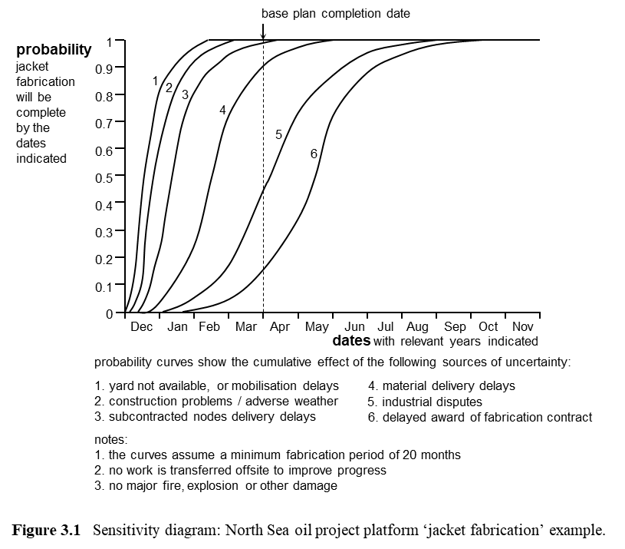

Figure 3.1 curve 6 portrays the joint effect of six ‘sources of uncertainty’ which had been quantified (using a prototype HAT approach) and combined making appropriate statistical and causal dependence assumptions. Some of these ‘sources’ involved further decomposition not portrayed by this diagram (source 1 for example – with two components explored shortly). Curve 1 portrays the effect of source 1, curve 2 portrays the effect of sources 1 + 2, curve 3 portrays 1 + 2 + 3, and so on. The gap between the curves portrays the potential impact of each successive source. For example, Figure 3.1 indicates that source 1 might have zero impact or lead to an assumed maximum delay of about two months, and source 2 adds about a week to the minimum, a couple of weeks to the maximum.

The ‘base plan completion date’ at the end of March was an estimate initially inherited by the project manager from earlier feasibility studies, to be adjusted if necessary. Curve 6 suggests a chance of achieving this date in terms of the assumptions used of about 15%.

Sources 2 and 3 were clearly relatively unimportant, source 4 slightly more important than 2 or 3, but less important than sources 5 or 6. Figure 3.1 and variants of this kind of sensitivity diagram could be used by all the people involved in undertaking and interpreting the analysis, in different ways at different times, to communicate effectively, and to drive the way the analysis was pursued effectively. Everyone needed to be aware of the relative size and importance of the complete set of sources as currently assessed in quantitative terms. They also needed to understand the role of the conditions (associated assumptions) flagged by the notes, an important form of qualitative analysis of uncertainty that required understanding for unbiased interpretation of the quantitative analysis.

There was no role for a variant of Figure 3.1 underlying the line A portrayal of option A in the Figure 2.2 decision diagram discussed in Chapter 2, because the Figure 2.2 approach used only one source of uncertainty. However, in the BP context Figure 3.1 proved itself very helpful at several levels for a number of purposes, and the way it was used provides an initial illustration of both the value of decomposing uncertainty and the value of an iterative approach to using the results.

The ordering of the sources in a sensitivity diagram like Figure 3.1 has three kinds of rationale which need understanding.

One is the value of ordering sources of uncertainty in a way which reflects time sequence and causality directions for storytelling purposes. For example, source 1 in in Figure 3.1 is the first source of uncertainty encountered, and source 2 cannot be encountered until source 1 has been overcome.

A second rationale is the importance of ordering to reflect dependence relationships which may need formal causal modelling or formal conditional dependence specification structures. If the nature or characteristics of source n depends upon source n-1 outcomes, that is the ordering needed. Sometimes source n may have a very complex relationship with source n-1, n-2 and so on, what is often referred to as a ‘cascade effect’. Facilitating a sophisticated understanding of relevant aspects of dependence can be a very important aspect the ordering of uncertainty sources.

A third rationale is the value of ordering sources to facilitate delivering specific messages. For example, the ordering of the sources in the Figure 3.1 format, with the potential impact of source 6 added last, provided a very useful basis for encouraging those responsible for letting the contract to avoid delays if possible. The project manager who selected the Figure 3.1 format initially had a message he wanted to communicate effectively to the managers responsible for possible delays to the award of the contract: ‘if the chance of delayed award of the fabrication contract can be eliminated, then the 0.15 probability of achieving the base plan completion date at the end of March (as indicated by curve 6) is increased to 0.45 (as indicated by curve 5)’. That is, curve 6 portrays the effect of all six sources, and removing source 6 means curve 5 becomes the new overall total.

Other people subsequently made effective use of Figure 3.1 in other ways. For example, the planner who initially estimated the source 5 contribution based it on extensive industry knowledge but no direct analysis of data. He was motivated by the relative size and importance of this source to systematically search for data and analyse it carefully. Analysis of available data confirmed he had sized the uncertainty correctly, but indicated he had misunderstood the underlying causes and how it might be dealt with. The industrial disputes in his data set had all occurred towards the end of contracts when no more work was coming into the yard – the workforce was facing layoffs. This was one of the consequences of a ‘feast or famine’ unstable market for this kind of dry dock facility, and unstable prices and market inefficiencies were probably further consequences. If energy majors could collaborate on the timing of their demand for these facilities, they could probably get better prices for jacket fabrication contracts in addition to reducing industrial dispute problems, a recommendation which the project manager later took to the board.

Key roles for underlying source-response diagrams

The planner who sized the two components of source 1 needed to separate them initially to think about two mutually exclusive issues which might delay getting started at the contracted date: unfinished work in the yard might require completion, causing delay to BP’s project, or if the yard had not been used for some time, acquiring a fully trained workforce might lead to significant delays. Combining them as source 1 was subsequently convenient for most purposes, but they needed initial consideration separately.

Everyone concerned with formulating and interpreting Figure 3.1 needed to be aware that a carefully composed qualitative analysis framework underlay the Figure 3.1 portrayal of the quantitative analysis results. Figure 3.2 illustrates the portion of it associated with source 1.

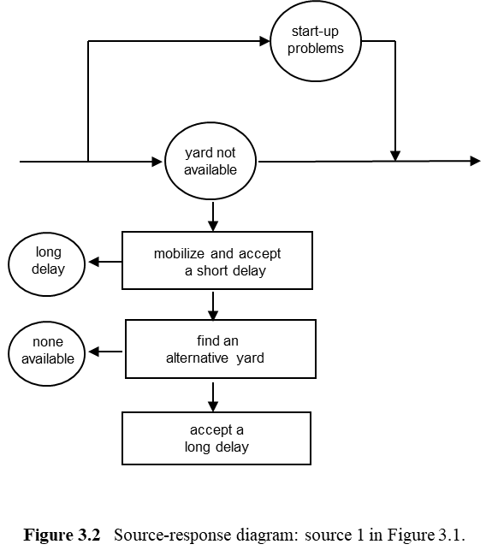

The qualitative analysis portrayed by Figure 3.2 clarified assumptions which the planner who produced curve 1 on Figure 3.1 had to understand before he addressed quantitative analysis, and his colleagues might need to understand to interpret curve 1. BP would not respond to ‘start-up problems’, leaving the yard to deal with them. A short delay due to ‘yard not available’ would be accepted, with ‘mobilise’ involving perhaps the delivery of steel to an adjacent site. If a long delay was involved, BP would try to find an alternative yard. But if an alternative yard was not available, BP would have to accept a long delay.

Further specific decomposed sources of uncertainty which could all happen followed on to the right, for as many pages as necessary. ‘General responses’, dealing with an uncertainty residual of all specific responses to identified specific sources, were shown on the far right-hand side. Preventative responses which could be specific or general were discussed in notes above. All relevant dependencies were highlighted in appropriate ways. The systematic generation, discussion and documentation control associated with the use of Figure 3.2 variants addressing all sources of uncertainty and all proactive and reactive responses for all project activities plus all the identified interdependencies was central to the process developed for BP and the understanding of uncertainty which that process delivered.

Everyone involved agreed that the quality of the qualitative thinking and associated formal analysis underlying the quantitative analysis was greatly improved by this flexible approach to the portrayal of the qualitative analysis, and effective communication of the rationale for all recommended decisions was greatly enhanced as well. Further, the way Figure 3.1 and 3.2 variants for all project activities contributed to a systematic documentation of the basis of decisions was soon seen as invaluable for a wide range of reasons, including ‘capturing corporate knowledge’ for reuse on later projects as well as later in the current project.

Concluding reflections

In terms of the Figure 1.6 discussion of clarity efficiency in Chapter 1, the discussion of this chapter is about points in the region from b₂ to b₁ on the clarity efficiency boundary. The pipelaying discussion might be associated with point b₁, and the jacket fabrication discussion might be associated with point b₂, because the fabrication activity did not require a month by month analysis approach or the same level of sophistication in terms of primary or secondary sources of uncertainty. The discussions in Chapters 1 and 2 were about point ‘c’ and the region between point ‘c’ and point b₃. Most organisations in most contexts need enough operational knowledge about the region between point ‘c’ and point b₂ to understand in broad terms the implications of the simplifications they are using on a routine basis when working in the region between points ‘c’ and b₂. But they also need some conceptual understanding of the region between points b₂ and b₁ to enrich their operational skills and provide the insight necessary to seek help when levels of clarity beyond their current skillset seem to require attention.

What this implies will become clearer in following chapters. In some respects, seeking clarity efficiency is a very simple idea, but in other respects seeking clarity efficiency is a very subtle proposition which requires an evolving understanding.

A key aspect explored in this chapter is the clarity enhancement provided by decomposing uncertainty about how long a project activity might take. Using the pipelaying examples, some source of uncertainty components might involve variability uncertainty (weather in terms of wave heights for example). Other components might involve event uncertainty (wet buckles for example). Ambiguity uncertainty was often involved (detailed plans deemed not worth addressing until later in the lifecycle, like the use of a simple productivity variations provision per month, with considerable concern for lack of bias for the expected value, but little concern for variability which would cancel out over the activity duration). Systemic uncertainty was generally crucial. The HAT approach facilitated a sophisticated approach to general and specific contingency planning responses to deal with causal dependency structures as well as sophisticated approaches to statistical dependence. Capability-culture uncertainty sources were not addressed in these studies, and were not a problem at that time.

To some extent the additional effort associated with this detailed decomposition of uncertainty sources was offset by using a much simpler activity decomposition structure for the strategic planning being addressed than had been the practice earlier – a target of 20 activities with an upper limit of about 50 for £ billion projects, instead of the hundreds of activities used before a prototype systematic simplicity approach was adopted.

To help to clarify the relationship between the Figures 3.1 and 3.2 treatment of jacket fabrication duration and the Chapter 1 single source of uncertainty treatment of William’s design change activity, first observe that the Figure 3.1 note 1 assumption ‘the curves assume a minimum fabrication period of 20 months’ was a starting position minimum feasible duration assumption comparable to a P0 for William. It was used to define the x-axis dates scale origin point as the beginning of December. Source 1 on its own could account for a delay of more than two months in terms of the P100 for the curve 1 estimate. A possible delay of more than 10 months was implied by the P100 value of curve 6. The P0 value of curve 6 was late January, but an arguably much more useful curve 6 plausible minimum was defined by the P10 in March, close to the end of March ‘base plan completion date’. A diplomatic way to refer to the ‘base plan completion date’ might have been a ‘plausible stretch target’, but a need for diplomacy about this issue did not arise. A comparably robust plausible maximum associated with curve 6 was a P90 in mid-July, implying an eight month P10 to P90 range. Note 3 indicates the kinds of adverse extreme events which curve 6 does not attempt to measure, and note 2 indicates the nature of further contingency planning which might marginally improve the outlook – a possible opportunity not yet explored.

Everybody using Figures 3.1 and 3.2 who understood the overall approach appreciated what had been measured, what had not been measured, and the implications for the base plan completion date which the project had inherited from a much early concept strategy stage estimate that the current project manager and his team had not been involved in. They also understood that the additional clarity relative to the approaches used earlier was very worthwhile, and it had been acquired using a very effective and efficient process for clarifying preventative and reactive contingency planning that all well-founded plans facing complex uncertainty needed to address.

This chapter has outlined the nature of the planning process BP developed based on a gradually evolving perspective that was ultimately driven by a clarity efficient quest for risk efficiency in an opportunity efficiency framework. But this chapter has not discussed the central role of the decision diagrams used to achieve risk efficiency. By the time prototype systematic simplicity analysis of the first BP offshore North Sea project was complete, the quest for risk efficiency was seen as the central issue by everyone involved.

The next two chapters focus on some key features of risk efficiency which you need to understand in a high clarity framework in order to understand why seeking risk efficiency is important, and why from a systematic simplicity perspective any approach to management practice which does not explicitly address risk efficiency needs to be replaced by one that does.

Chapter 4 A high clarity demonstration of risk efficiency and enlightened caution

A high clarity demonstration of risk efficiency

As explained in Chapter 2, a ‘risk efficient’ choice provides a minimum level of risk for any given level of expected outcome in terms of any given attribute of interest. For each attribute of interest, expected outcome and associated risk are two different but interdependent performance criteria treated as separate objectives. In the context of risk efficiency, ‘risk’ means the possibility of a ‘reward’ (positive) objective outcome which is less than that expected, or the possibility of a ‘cost’ (negative) objective outcome which is greater than that expected. Figure 2.1 portrays the risk efficient boundary we want to be on, and Figure 2.2 provides a simple linear decision diagram tool for achieving this in many circumstances. However, a higher clarity portrayal of risk may be important, especially if the probability distribution associated with any of the possible option choices involves significant asymmetry.

Figure 4.1 is a useful illustration of a high clarity decision diagram portrayal of risk efficiency illustrating an enlightened caution choice. It was used initially during the assessment of the first BP project using the prototype systematic simplicity approach.

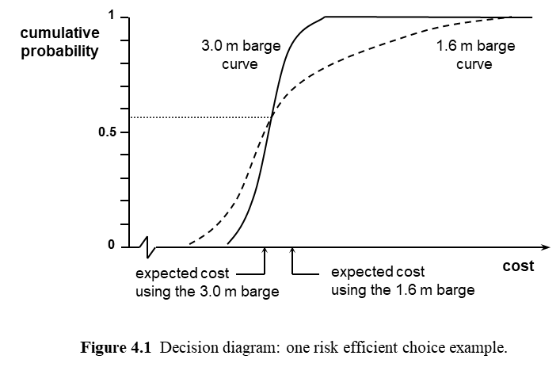

Figure 4.1 was employed by a BP project manager to compare the use of a 3.0 m (metre) wave height capability barge and a 1.6 m barge to complete a ‘hook-up’ activity. This hook-up activity involved using a ‘hook-up barge’ to connect an installed platform to the pipeline laid by a lay-barge. The initial base plan assumed this hook-up activity would take place in August using a 1.6 m barge. However, the analysis of all relevant sources of uncertainty prior to completion of both pipelaying and platform installation in addition to sources of uncertainty during the hook-up activity suggested hook-up being completed in August was unlikely, October or November were more plausible targets, and there was about a 10% chance that a spring completion would be needed if the 1.6 m barge option was selected. The knock-on costs of ‘going into a second season’ were of the order of £100 million. It was the 10% chance of an extra £100 million that initially triggered considering a 3.0 m barge, which would cost more than twice as much per working day, but cope with much worse weather. There was a better than 50% chance that the 1.6 m barge would prove cheaper than the 3.0 m barge, as shown by the point on Figure 4.1 where the two curves cross; but the expected cost of using the 3.0 m barge was less, by about £5 million; and the risk associated with the 3.0 m barge was also less.

What the project manager understood clearly from this decision diagram was in terms of cost as measured he only had one risk efficient choice – the 3.0 m barge. Its expected cost was about £5 million less, and it was much less risky, because its cumulative probability curve rose relatively vertically. The exact shape of the 1.6 m curve did not matter, but the long right-hand tail driven by a possible delay until the following spring had two implications which both mattered. The asymmetric uncertainty associated with the long tail of the 1.6 m curve dragged the expected cost value to a level well above the 3.0 m barge option, in addition to exposing BP to the risk of a cost outcome well above the expected value.

What later users of this high clarity approach to achieving risk efficiency understood was this was a good example of using what became known as ‘enlightened caution’. Using enlightened caution involves understanding how to look for and chose options which will be more expensive most of the time, but risk efficient (less expensive on average and less risky), because the alternatives which are less expensive most of the time have a highly asymmetric probability distribution involving very high possible values. Another way to look at this is avoiding ‘unenlightened gambles’, defined as gambles which are not risk efficient – on average it does not pay to take them.

Using this example to illustrate clearly why risk efficiency matters

When the project manager eventually completed the analysis of his whole project for the E&D strategy stage and used it to seek approval for his strategic plans by the board, with a budget and a mandate to start detailed planning, he took Figure 4.1 to the board with the 3.0 m barge for hook-up associated with a revised base plan. He used Figure 4.1 to help explain the concept of risk efficiency now being sought as a central driving concern for the new planning process which this project had been pioneering. He explained that this one decision to switch from a 1.6 m hook-up barge to a 3.0 m hook-up barge increased the expected return (reduced the expected cost) by about £5 million, and simultaneously reduced the risk of cost overruns.

He emphasised that this particular decision was a close call, what later became known as an example of ‘enlightened caution’, because it needed a high clarity decision diagram supported by a high clarity decomposition of uncertainty to identify and communicate what was involved. He did not use the term ‘enlightened caution’ at the time, but he clearly understood the usefulness of this particular example, and he explained that his project planning team had often uncovered massive increases in risk efficiency which were more obvious, comparable to the 3.0 m barge curve being even farther to the left. He emphasised Figure 4.1 played an important role in his planning team’s understanding because it made them all clearly aware of the need to search for opportunities to employ specific and general responses which were both proactive and reactive to reduce expected cost and risk simultaneously.

He also believed it was an especially useful example for demonstrating clearly to the board why planning based on the use of high clarity decision diagrams like Figure 4.1 to ensure all important choices were risk efficient was an investment in much better decision making which provided a high expected rate of return at a lower level of risk. This new planning process was not just about giving them comfort that duration and cost estimates were unbiased. It was about reducing expected cost in order to increase expected reward in conjunction with less risk.

He did not cite the £100 return for every £1 invested in this kind of analysis later used regularly by a very senior MoD colleague, who implemented the MoD study discussed in Chapter 1 and many others. Nor did he spend a lot of time explaining that the proactive response to hook-up activity delay which a change to the 3.0 m barge involved could be seen as both a specific response to dealing with bad weather during the hook-up activity and a general response to delays to the preceding pipelaying activity and all of its preceding activities plus delays in the preceding jacket installation activity and all of its preceding activities. However, he did make it clear that in terms of the project as a whole, the new planning approach delivered a massive expected return on investment in terms of reducing expected overall project cost, and associated overall project cost risk was reduced, and he believed unbiased estimates providing well-founded confidence in project duration and cost estimates should now be the norm.

Budgets based on enlightened provisions and contingencies

The board approved his plans plus a budget set in a new manner based on clearly defined contingencies as well as provisions, and the project came in on-time and within budget, despite some surprises. Provisions were expected expenditures based on all quantified sources of uncertainty reflecting statistically and causally modelled dependencies using the HAT framework. Contingencies involved a further uplift, which should not be needed on average as assessed using quantitative analysis, to provide an 80% chance of staying within budget in terms of the quantified uncertainty. In the board’s judgement this was deemed to be an appropriate level of confidence for a budget figure. It was comparable to a commitment target in some respects, but it was explicitly based on the B₂ penalty cost approach to a balanced target addressing too much verses too little contingency. It did not embrace the full set of more general ‘commitment target’ properties which could be associated with a P90 mentioned in Chapter 1. But it did address some governance and other cost trade-offs. And from the outset it formally recognised that some of the identified conditions might not hold (not all identified sources of uncertainty had been quantified, as illustrated by the ‘notes’ on Figure 3.1). Later it also acknowledged that some previously unidentified surprises should be expected.

It is important that some ‘unknown unknowns’, as ‘surprises’ were referred to later, should be anticipated, even if their nature was inherently unpredictable. Indeed, a very important part of the role of ‘general responses’ in terms of achieving risk efficiency was coping with what was inherently unpredictable plus what was not worth predicting given the robustness of a rich general response set.

Further, in terms of setting budgets and controlling expenditure, dealing with unknown unknowns effectively and efficiently is important. The term ‘enlightened provisions and contingencies’ was not used at the time, but it might be a useful term to apply now, if the complete set of provision and contingency sums explicitly covered both the known and unknown unknowns and the uplift associated with the 80% confidence level for the quantified uncertainty in a way which reflected an appropriate corporate penalty cost function associated with being under or over budget.

Concluding reflections

In addition to approving this particular project, the board also endorsed the new project planning process it had pioneered and decided to mandated it on a worldwide basis for all future large or sensitive BP projects. After about five years the unbiased nature of the new approach to estimates was verified by statistical analysis of estimates and outcomes. The eight years that I worked with BP was one of my career’s most successful partnerships, and I remain deeply impressed by all the BP people that I worked with. Robin Charlwood, an Acres Consulting Services colleague I am still in touch with, introduced me to the BP project managers to trigger the initial contract, and BP software as well as BP prototype systematic simplicity approaches were subsequently used for a series of Acres clients in Canada and the USA.

After about a decade the mandated BP systematic simplicity prototype approach to project planning was changed again, as part of a significant portfolio of other changes in approach. The driver of these changes was BP moving away from direct management of project risks towards letting their contractors manage risk. The overall consequences of the board changing approaches again after a decade were complex, relevant to the next chapter, and touched on again later in this book.

Chapter 5 Enlightened gambles and enlightened prudence

Sometimes taking more risk as a culture change proposition

In the 1990s I accepted an invitation to play a role in the IBM UK Forum 2 programme which had a significant impact on my understanding of a systematic simplicity perspective. The Forum 2 programme was designed by IBM senior executives and training staff with my support to change IBM corporate culture. The change involved a new focus on most IBM decision makers taking more risk as well as systematically seeking risk efficiency, understanding that both achieving risk efficiency and taking more bearable and acceptable risk were essential to avoid important corporate level risks associated with changes in the market place and the nature of their competitors. The idea that it might be desirable, even essential, for any decision makers to deliberately take more risk was initially counterintuitive for many of those involved. But the necessary culture change required everyone becoming convinced that in most contexts they needed to take more risk knowing what they were doing, always embracing a risk efficiency driven approach to all management decision making, sometimes exercising prudence. Clarity about the role of enlightened caution coupled to a distinction between enlightened and unenlightened gambles and the role of enlightened prudence was enthusiastically welcomed by everyone involved, and seen as central to both knowing what they were doing using a new decision making approach and the behavioural changes needed. Taking more of the right kind of risk as well as less of the wrong kind of risk was the explicit IBM goal, within a process based on achieving risk efficiency. This is a crucial aspect of understanding opportunity efficiency, which needs to be fully understood to achieve ‘best practice’ in any meaningful sense. But it is not a recognisable aspect of most common practice. That is part of the reason why organisations need to introduce and sustain the ongoing development of a systematic simplicity approach with a reasonably nuanced understanding of what is involved.

Building on an elaboration of the Figure 4.1 story

All senior and middle level IBM UK managers attended one of about 40 two-day sessions, with about 30 people at each session. The IBM UK Chief Executive Officer (CEO) spent about half an hour opening the first day of each session, introducing the agenda and explaining the objectives. I then spent the rest of the first morning on presentations. In the afternoon I used a carefully designed case study to link the morning’s messages to outlining what IBM staff had to do to implement the ideas. The second day was spent discussing implementation by the IBM staff in terms of their particular concerns, building on day 1.

My morning presentations on the first day started with the use of Figure 2.1 to provide an overview explanation of risk efficiency in terms of an efficient frontier perspective. Figure 4.1 was then used to explain how employing decision diagrams in a high clarity form by BP demonstrated to everyone involved that higher expected reward as well as less risk could be achieved even in very complex circumstances.

The ‘enlightened caution’ aspect of the 3.0 m barge choice decision made using Figure 4.1 was then explained, contrasting it to the ‘unenlightened gamble’ of the 1.6 m barge choice. The explanation outlined in the last chapter was then elaborated, starting by pointing out that the hook-up activity actually took place in October, in good weather. Given this outcome it was very important for the project manager’s reputation and future career prospects that the analysis provided after-the-fact evidence that the project manager had made the right choice, and managed the project very effectively to get to the hook-up by October, and BP had been lucky with the weather. The message being emphasised by this elaboration was using a prototype systematic simplicity approach had been crucial to BP making the best available choice in the first place, and it was also crucial to recognising that the best choice had been made after the activity had been completed when they might have got away with an ‘unenlightened gamble’. IBM needed comparable capability, based on in depth understanding of what always seeking risk efficiency involved, although in practice they might use much simpler tools than BP required, and formal analysis would not always be needed once the culture change took place.

A hypothetical ‘enlightened gamble’ decision was then considered using Figure 5.1. Creating Figure 5.1 for the Forum 2 programme involved simply moving the 3.0 m barge curve on Figure 4.1 to the right, so that the £5 million expected cost advantage for the 3.0 m barge on Figure 4.1 was transformed into a £5 million expected cost disadvantage for the 3.0 m barge on Figure 5.1. If the probability estimates involved in the actual case portrayed by Figure 4.1 had been different, Figure 5.1 might have been the result obtained by the BP planners.

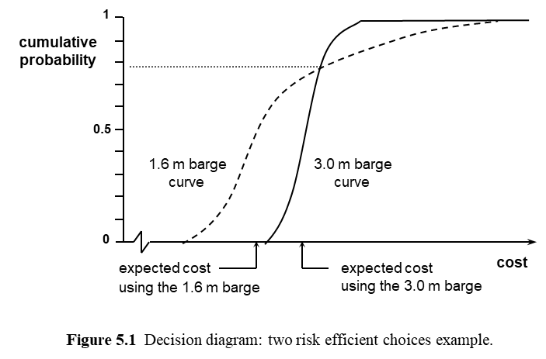

Two questions for IBM staff to address using Figure 5.1 were:
- ‘if this was the case, what would BP project planners probably do?’;
- ‘what messages should IBM staff take from this in terms of the need to sometimes take more risk, knowing what they were doing, as emphasised by their CEO?’

To address the first question, I suggested that the 10% chance of an extra £100 million associated with the long right-hand tail for the 1.6 m barge choice clearly needed to be understood by the project manager and communicated effectively to his board. Assuming that this was done, it was reasonable to assume the risk would be accepted to take advantage of the expected cost advantage of £5 million. The rationale was that this kind of project had an expected cost of about £1 billion in late 1970s £s, with possible ‘very bad luck’ scenarios doubling or trebling this amount. To cope with this level of risk BP often collaborated with other oil majors, sharing risks and rewards, a form of insurance/diversification. Having put these arrangements in place to cope with this high level of risk, at the £100 million level of risk involved here they could afford to accept the risk and maximise expected reward by minimising expected cost, and it was actually very important to see doing so as an opportunity.

In this case the 1.6 m barge choice would be an ‘enlightened gamble’, worth taking. And in this case, if the enlightened gamble did not pay off because they were unlucky, the risk involved was big enough to be worth using Figure 5.1 in advance to explain the nature of the gamble and the rationale for taking it to the board, so that if the extra £100 million ‘bad luck’ scenario arose this outcome would not be inappropriately associated with ‘bad management’.

If, over all of their projects, BP made 20 comparable decisions per annum, on average they would save about 20 x £5 million = £100 million, an important further boost to the expected profit increase driven by getting on the risk efficient frontier portrayed by Figure 2.1. In terms of the Figure 2.1 portrayal, in addition to moving from points like e₁ to points like b₂ for less risk and higher expected reward, they would be moving from points like b₂ towards points like b₁ for higher expected reward involving a bearable and acceptable increase in risk.

All IBM staff needed to appreciate that risk at a corporate level needed effective management, and at a corporate level a very complex portfolio of corporate strategic management issues were involved, some requiring enlightened prudence. However, most IBM staff were focussed on operations and project management concerns at a level where taking enlightened gambles as well as achieving risk efficiency should be the focus most of the time. They needed to be aware of the need for ‘enlightened prudence’ in some circumstances, and when appropriate they might need to test for a possible reduction in risk in a risk efficient manner to avoid taking an imprudent level of risk. They also needed to be aware that the boundary between enlightened gambles and enlightened prudence was sometimes not a simple or straightforward matter. But they needed to be clear that avoiding risk because of prudence concerns was not the central issue most of the time at their level of decision making.

In a context like Figure 4.1, the 1.6 m hook-up barge choice was an ‘unenlightened gamble’ in the sense that it was risk inefficient – it involved less expected reward and more risk. The ‘enlightened caution’ 3.0 m hook-up barge choice was the only risk efficient option in the context of Figure 4.1. Most of the time a single risk efficient choice would be much more obvious, with any risk inefficient choice curves further to the right. Crucially, once people understand what they are looking for, and how the relevant supporting tools for making decisions within a systematic simplicity approach work, they might not even need to use the tools in an operational form much of the time. The tools would become part of a conceptual toolset and mindset which would help to transform the culture.

In a context like Figure 5.1, the 1.6 m hook-up barge choice was an ‘enlightened gamble’ in the sense that a risk efficient choice involving less risk was available, but the risk involved was well within the organisation’s risk taking capabilities, and the risk involved was worth accepting to achieve the additional expected reward. The organisation should have a ‘risk appetite’ concept defined in a risk efficiency framework which facilitated taking this level of risk and recognised that some enlightened gambles would involve unfavourable outcomes.

If the ‘bad luck’ scenario associated with Figures 4.1 or 5.1 was not a 10% chance of an additional cost of £100 million, but a plausible chance of an additional cost of £100 billion, arguably the gamble would clearly be imprudent and inappropriate whether or not a higher expected reward was involved.

Selective use of decision diagrams like Figures 4.1 and 5.1 can be the key to corporate clarification of the difference between bad luck and bad management, or between good luck and good management. This can help to drive a very fundamental and important culture change, based on all relevant decision makers taking the right kind and level of risk based on the right kind of analysis. Very clear corporate understanding of why inappropriate risk avoidance and associated counterproductive ‘risk appetite’ concepts unrelated to risk efficiency need to be eliminated has to be part of this movement to a new kind of ‘managing opportunity culture’. Taking appropriate gambles with a ‘no inappropriate blame’ culture should be a clear goal that everybody understands, with everyone accountable for the quality of their decision making. Avoiding confusing good or bad luck with the quality of the decision making can be a fundamental and transformative aspect of a required culture change.

All of these culture change ideas need to be understood by all relevant parties to effectively implement a systematic simplicity approach. Further, organisations need to invest in a comprehensive understanding of the underlying conceptual tools, like the clarity efficient frontier portrayal of an opportunity region provided by Figure 1.6, and the risk efficient frontier portrayal of an opportunity region provided by Figure 2.1. Operational tools matter too, like decision diagrams and sensitivity diagrams. Relevant staff need an appropriate conceptual level of understanding of high clarity decision diagrams like Figures 4.1 and 5.1, plus high clarity sensitivity diagrams like Figure 3.1 and underlying source-response diagrams like Figure 3.2. They also need to be comfortable with operational use of lower clarity variants of decision diagrams like Figure 2.2. If this can be achieved, much better decision making using a lot less effort should become the norm, a step change in terms of a whole new vision of what ‘best practice’ ought to mean, and why introducing systematic simplicity to manage decisions in terms of seeking opportunity efficiency is essential.

Developing an effective understanding of how to use Figure 2.2 format simple linear decision diagrams was central to the IBM Forum 2 case study exercise, building on the understanding of Figures 4.1 and 5.1 developed during earlier presentation discussions. The IBM case study exercise began to explore the multiple attribute concerns associated with opportunity efficiency as discussed in Chapter 2 of this book, using a bidding context which all IBM staff could associate with, even if they were not directly involved in sales. The context was suggested by a senior IBM executive who helped to guide my design of the overall approach. It drew on my understanding of the kinds of issues discussed in Chapter 2, but it soon took me well beyond my prior expectations of what was feasible, and it proved to be a significant learning experience for me as well as for the IBM staff. For example, I built into the case study an option to use a subcontractor which involved a lower expected cost but the risk of a hostile takeover with possible adverse effects which could be significant. My purpose was to see if they would take account of the ‘red light’ test aspects of this risk. One IBM bidding team came up with a ‘friendly takeover’ strategy which generated a ‘blue light’ linked to the longer term corporate advantages of keeping this subcontractor available to IBM, unanticipated creative thinking built into the Enlightened Planning chapter 6 discussion. In my view just over the first day of their Forum 2 programme many of the IBM staff developed a much more sophisticated and nuanced understanding of opportunity efficiency in terms of multiple attributes and the importance of attributes which were not easily measured than some of the BP project planners I worked with for several years, although the IBM staff clearly did not acquire the depth of understanding of BP project planners in some other areas.

Concluding reflections

One general lesson which I drew from the Forum 2 programme was the importance of all the IBM staff involved understanding how the high clarity tools operate in conceptual terms, plus how simpler low clarity variants can often meet the required decision making needs with less effort if the higher clarity option is used as an effective alternative to ‘useful theory’. This was clearly illustrated by the conceptual importance of Figures 4.1 and 5.1 coupled to the practical application of Figure 2.2 variants.

A second general lesson was how important creativity is, illustrated by the friendly takeover counter to the hostile takeover threat identified by IBM staff during their case study exercise.

A third general lesson was how different people working in different areas can take advantage of the same basic systematic simplicity frameworks and concepts to achieve significant management decision making improvements involving creative adaptation to the context. This was illustrated by IBM safety management staff developing a very sophisticated understanding of how to justify a much simpler and significantly less expensive approach to meeting UK building regulations on fire safety as well as IBM international corporate rules using my consultancy support on a separate contract triggered by Forum 2.

For any organisation, a carefully designed in-house programme comparable to the Forum 2 programme should be able to equip people engaged in a wide range of roles with sufficient understanding of what is involved to get them started in their areas of particular focus. But the design of a Forum 2 programme equivalent which is best suited to all the context features of any given organisation is not a simple matter, and there are many other alternative routes to organisations adopting and developing a systematic simplicity approach. Some recommended options are briefly explored in the final chapter of Part 2.

Chapter 6 Bias as a symptom of multiple sources of opportunity inefficiency that matter

Basic uncertainty decomposition concerns

Using systematic decomposition of uncertainty as part of achieving opportunity efficiency involves a complex set of interdependent issues that are highly controversial. This chapter addresses some of these issues and their implications. Later chapters address some more.

Very basic and obvious concerns most management decision making processes ought to address are how to decompose uncertainty into multiple sources of uncertainty in a clarity efficient manner, and what level of clarity ought to be sought in terms of this decomposition. When addressing these concerns, less obvious underlying issues include what exactly is the set of purposes and associated priorities of the decomposition process, and does everybody involved have the same well-founded understanding of the rationale for uncertainty decomposition at an appropriate level of clarity in any particular context.

The rationale for all decomposition of uncertainty in a systematic simplicity framework is ‘the additional clarity provided is worthwhile because the right kind of decomposition has been chosen and the level of effort expended pays dividends’. People who do not understand opportunity efficiency and the component risk efficiency and clarity efficiency concepts invariably see the nature of decomposition choices very differently, and sometimes the implications are seriously inept decision making for complex sets of reasons which are not easily explained but need broad understanding. This chapter provides an overview of some the common misconceptions which are usefully addressed before finishing Part 1 of this book.

A UK Highways Agency example

Prior to 2007, the UK’s Highways Agency (now Highways England within England) adopted a very widespread common practice approach to these issues when estimating the cost of the UK roads they were responsible for. When a House of Lords enquiry severely criticised the Highways Agency because of routine serious cost overruns, the Secretary of State for Transport responded by commissioning a report from Mike Nichols (Nichols, 2006). I worked with Mike and a small team to help write his report, and when this report was accepted by the Highways Agency, I worked with a Nichols Associates consulting team to initiate the implementation of suggested changes. This assignment began by re-estimating the cost of about £20 billion worth of highway projects in various stages of development.

Nichols consultants and Highways Agency staff used a variant of Figure 6.1 to re-estimate the costs of a sample of proposed new motorway projects in the first stage of their lifecycles, the ‘concept strategy stage’. ‘Concept strategy stage’ is Enlightened Planning terminology, and Figure 6.1 is an averaged and normalised version of the individual diagrams actually used for each of the sampled Highways Agency (HA) projects. Figure 6.1 uses a base estimate value of 100% as employed by Hopkinson, Close, Hillson and Ward (2008), also used by Enlightened Planning, to preserve confidentially and summarise the sample involved.

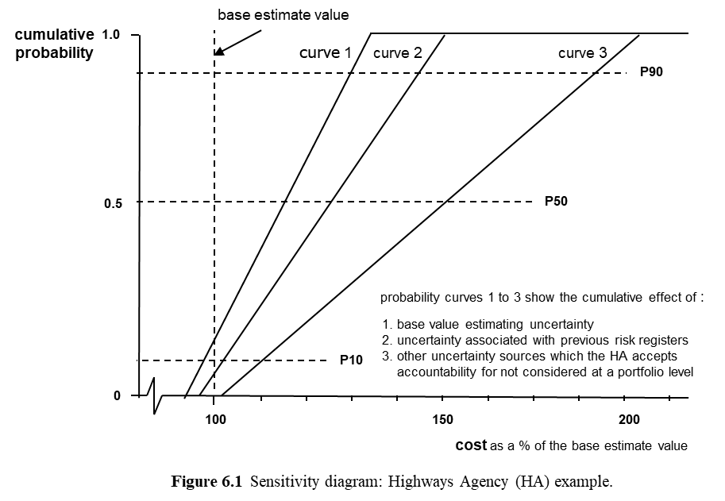

Figure 6.1 is a linear sensitivity diagram using three sources of uncertainty to provide a simple but carefully designed moderate clarity portrayal of uncertainty sources. It is a variant of the Figure 3.1 high clarity sensitivity diagram portrayal of six sources of uncertainty used in Chapter 3 to discuss uncertainty associated with a BP offshore oil project’s ‘jacket’ fabrication activity duration.

The original HA estimation approach involved starting with the ‘base estimate value’ associated with Figure 6.1, a traditional single value point estimate of this project’s cost as estimated in the concept strategy stage. This was followed by the HA using a traditional project risk management estimate of the ‘risk adjustment’ needed to eliminate what was referred to as ‘optimism bias’, as required by HM Treasury guidelines at the time (HM Treasury, 2003a and 2003b).

After the HA estimator who provided each base value estimate was given an introductory overview of the whole re-estimation process, so they understood each step of what was coming, they were asked to begin the re-estimation process.

Curve 1 was addressed first. The estimator was asked to review their understanding of all the uncertainty which they had considered when assessing the original ‘base estimate value’, using any notes or other records available, with a view to defining curve 1.

The estimator was then asked to estimate the P90 value followed by the P10 value defining curve 1, a minimum clarity estimate portrayed in cumulative probability distribution form. Estimators were initially surprised and concerned that the P50 interpreted as an expected value was about 15% larger than their base value. However, after unconscious bias associated with effects like ‘anchoring’ when initially focussing on most likely outcomes given reasonably optimistic working assumptions was explained, and the way this bias can be reduced by an initial focus on a plausible pessimistic outcome like a P90, plus the way a very long tail on the right-hand side of the presumed underlying reality Figure 1.2 curve as discussed in Chapter 1 can pull the expected value to the right, they became comfortable with curve 1 and its implications.

Curve 2 was then addressed, first assessing its P90, then its P10. Curve 2 involved adding the additional uncertainty associated with the original ‘risk adjustment’ so the sum of source 1 plus source 2 was portrayed by curve 2. The simplest available interpretation of the process required to produce curve 2 was used – a separate minimum clarity estimate of the ‘risk adjustment’ cost probability distribution provided by the traditional project risk management approach was assessed in terms of its P90 and its P10. This source 2 probability distribution was then added to source 1 to define curve 2 assuming 100% positive dependence between these two sources.

The 100% positive dependence assumption, implying all percentile values coincide as a simple but flexible and general interpretation of perfect positive correlation, can seem excessively pessimistic to people who are not familiar with its use. Statistical independence (0% dependence) is a common default assumption which many people initially prefer to 100% positive dependence. But 100% positive dependence is usually much closer to the underlying reality than 0%, it is easier to use, it usually (not always) errs on the pessimistic side to a modest degree which helps to offset other residual optimism bias, and if its use suggests an intermediate percentage dependence or a more sophisticated dependence framework would be worthwhile, there are a rich range of options available for seeking more clarity in an effective and efficient manner.

Two sources of uncertainty which needed consideration at portfolio level by the HA were then explored to clarify their exclusion from the current assessment, referred to as source 4 and source 5. Source 4 was inflation, which clearly applied to all projects and needed consistent treatment for all projects. It was best addressed separately at a much later stage in the project lifecycle. Using money of the day estimates and avoiding accepting accountability for this source of uncertainty until a contract was signed had now become recommended HA policy. Source 5 was all other portfolio level sources of uncertainty which the HA could reasonably be deemed accountable for, best addressed later at a portfolio level, like changes in the ‘quality’ of motorways due to changes in EU regulations or comparable HA policy changes – stronger crash barriers between separated lanes for travel in opposite directions, for example.

Curve 3 was then addressed, first assessing its P90, then its P10, as a separate probability distribution for source 3. Source 3 involved all sources of uncertainty which the estimator could now see were:
- specific to this project (not part of sources 4 or 5), and
- the HA could reasonably be held accountable for them, but
- they were not covered by sources 1 or 2.

Examples included a wide range of working assumptions which were unlikely to hold exactly, addressing issues like the type, nature and effectiveness of contracts with the main contractors and all their subcontractors, the capability of the main contractors and all the subcontractors, the actual length of the route between the outcome versions of the assumed route points, the availability of the assumed materials of preferred types and qualities, and market pressures affecting a wide range of prices and other supply concerns with implications not covered by general inflation. The competence of all relevant HA employees was also part of this residual source 3 uncertainty, plus the timeliness of required government decisions which might be influenced by the project team with consequences attributable to the HA.

In effect, source 3 has to be seen as an explicit ‘closure with completeness’ concept, a category or component of uncertainty explicitly addressing all sources of uncertainty not included in sources 1, 2, 4 or 5.

Source 3 was added to sources 1 + 2 to define curve 3 assuming 100% positive dependence.

Estimators were not surprised that sources 1 + 2 + 3 provided an expected 50% uplift to their base value estimate starting point, because this was the level of bias typically involved in their original estimation process in terms of these three sources. And they were very comfortable with the approximately 15% + 10% + 25% contributions associated with sources 1, 2 and 3.

Estimators were surprised, and very pleased, that simply asking them a new set of simple but very different questions produced an answer which seemed approximately correct. So were most of the other HA staff involved.

However, a few of the HA staff who were responsible for the extensive decomposition of source 2 using ‘traditional project risk management’ methodology were concerned that this result was directly critical of their approach.

To clarify the term ‘traditional project risk management’ methodology in terms of key defining features for present purposes, it used:
- a ‘risks’ concept limited to sources of event uncertainty associated with events or conditions which do or do not happen/hold, portrayed using probability-impact grid representations, often involving long lists (significant decomposition detail);
- no direct consideration of sources of variability uncertainty;
- no direct consideration of sources of ambiguity uncertainty;
- limited attention to interdependencies between risks and systemic uncertainty more generally;
- no recognition of the important difference between specific and general responses;
- a focus on reducing the impact of ‘risks’ without any direct explicit attention to risk efficiency and the associated issues addressed earlier in this book, including clarity efficiency and opportunity efficiency.

Those who were concerned about Figure 6.1 did not say so directly, but they seemed to believe that the traditional approach they had advocated was ‘good’ practice even if it was not ‘best’ practice because it was common practice that they and their colleagues had used for some time. They interpreted what Figure 6.1 demonstrated as a direct criticism of their professional judgement. In a sense it was. However, I am inclined to blame the profession collectively rather than the individuals. That is, any individuals who begin by following conventional common practice, and at some stage appreciate why changing to much better practice would be a good idea, have nothing to be embarrassed about as I see it. But professional bodies that continue to defend inappropriate approaches in project risk management guides and standards, despite widespread knowledge of the problems this causes, should not be allowed to keep getting away with it without increasing levels of public criticism. In this context you might like to know that HM Treasury (2014) acknowledged and supported the Nichols (2006) report, and Enlightened Planning provides evidence of significant further support for the need to revise project risk management guides and standards so they reflect a more enlightened perspective.

Just in terms of eliminating bias, Figure 6.1 clearly suggested that the focus on source 2 of the traditional methodology involved wasting time and effort, some of which could and should have been used much more effectively addressing the more significant overlooked concerns associated with sources 1 and 3 plus portfolio level uncertainty sources 4 and 5.

The very simple decomposition structure for sources of uncertainty used for Figure 6.1 was clarity efficient for its intended re-estimation task. As part of this task, it clarified the need to recognise explicitly the very wide uncertainty range associated with the expected construction cost of a new motorway in the concept strategy stage of its development, and it started to clarify the need to distinguish this initial uncertainty from the uncertainty underlying risk when construction contract commitments were made, as discussed in the 2006 Nichols report using a variant of Figure 6.2.

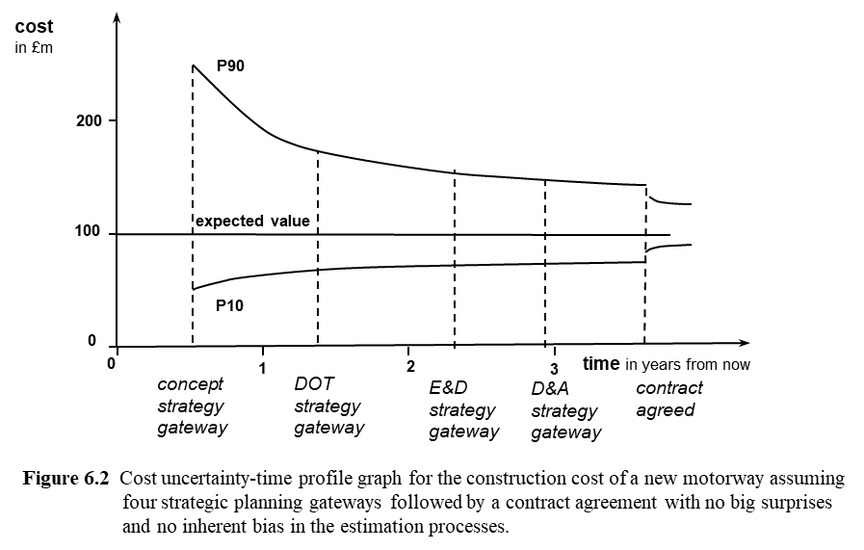

The terminology employed by Figure 6.2 has been taken from the Nichols (2006) report discussion used in chapter 7 of Enlightened Planning, which explains the rationale of the underlying project lifecycle structure. In brief, the concept strategy gateway stage is the board level approval process which completes the concept strategy stage, following the concept strategy process aspect. This gateway stage sanctions spending more time and money on developing design, operation and termination strategic plans (the DOT strategy stage). The DOT strategy gateway stage is the board level approval process which completes the DOT strategy stage. It sanctions spending further time and money on execution and delivery strategic plans (the E&D strategy stage). In addition to these first three strategy stages in their basic progress and gateway stage forms, it can be very useful to employ separate devils and angels in the details (D&A) planning at a strategic level with an associated D&A strategy gateway stage prior to contract agreement, assuming that detailed planning for implementation purposes will follow contract agreement.

Figure 6.2 assumes no big surprises as well as no bias causing the expected value to change over time. In practice there may be big surprises. For big surprises to be forgivable, the accountable parties should be able to provide reasonable explanations, and a systematic simplicity approach can help with these issues in ways discussed briefly in this book, more extensively in Enlightened Planning. For example, documentation can be crucial to help to demonstrate the difference between good luck and good management, bad luck and bad management, related to enlightened caution and enlightened gambles. Also, general responses can be designed to accommodate some (not all) ‘unknown unknowns’, to avoid them becoming ‘big surprises’ if at all possible. Some big surprises are invariably beyond effective anticipation.

Routine persistent bias involves a failure to use systematic simplicity in very basic ways. An illustrative example of how this can happen is provided by the significant detailed attention given to source 2 on Figure 6.1 while ignoring sources 1 and 3. For any organisation using traditional project risk management ‘risk adjustments’ linked to initial point estimates, the resulting serious understatement of the uncertainty considered at the concept strategy gateway means that the range of possible outcomes is severely understated. As illustrated by the discussion associated with Figure 6.1, the result will be an expected outcome which is seriously optimistically biased.

The wide P10 to P90 range associated with the expected cost estimate at the concept strategy gateway in Figure 6.2 is not all uncertainty relevant to ‘risk’ associated with the expected outcome when a contract is signed and commitment is made. It is largely uncertainty because of ambiguity which should be partly resolved prior to a contract being agreed. But the asymmetry of the associated probability distribution contributes to the expected value, and ignoring it contributes to biased expected value estimates. A key ‘risk’ which needs particular attention at the concept strategy gateway stage in a project’s development is a failure to achieve unbiased estimates of expected outcomes and associated ranges, leading to inappropriate decisions and failures of trust with knock-on implications which can be very serious – including projects done in the wrong way by the wrong contractors as well as doing the wrong projects.

The decomposition structure of the three sources of uncertainty used for Figure 6.1 was designed to capture what was currently being assessed (source 2) plus what could be captured immediately (sources 1 and 3) and should be captured later (sources 4 and 5) to get a complete picture of a variability uncertainty portrayal of all relevant uncertainty specific to this particular project to avoid biased estimation. Designing the decomposition structure to emphasise the need to deal effectively with two portfolio level concerns separately at a later point in time goes beyond immediate bias implications, but it was done to clarify the partial treatment of bias associated with sources 1 to 3 as well as the need to deal with sources 4 and 5 later.

A revised HA approach to estimation for ongoing use in all project lifecycle stages had to build on the insight provided by Figure 6.1 plus Figure 6.2. To do this it had to use a significantly modified decomposition of uncertainty structure, tailored to achieving clarity efficiency, risk efficiency and overall opportunity efficiency in the concept strategy lifecycle stage, with planned further tailoring adapting the process used as the project lifecycle evolved.

Any other organisation considering moving from a traditional project risk management approach to a systematic simplicity approach to all aspects of project management needs to consider the same issues, adapting their approach to the context. Earlier chapters in this book provide clear indications about some key aspects of what this involves, Part 2 of this book elaborates briefly, and chapter 7 of Enlightened Planning elaborates further.

People who are skilled at designing and developing clarity efficient approaches suitable for a range of different contexts need a familiar toolset to draw upon. One useful toolset component is an understanding of the range of levels of clarity which can be provided by different aspects or features of alternative approaches to uncertainty decomposition.

To begin to understand these issues and the nature of associated controversy is difficult because of the complexity, but they matter a great deal, so a broad understanding of the role of all relevant kinds of uncertainty which all approaches to decomposing uncertainty ought to facilitate thinking about is very worthwhile. As noted earlier, one way to visualise the decomposition of uncertainty involves five portrayals of uncertainty: variability uncertainty, event uncertainty, ambiguity uncertainty, capability-culture uncertainty and systemic uncertainty.

Variability uncertainty plus event uncertainty are clearly central concerns, and the discussion earlier in this book should have made it reasonably clear how these two aspects can be captured using a systematic simplicity approach to decomposing sources of uncertainty.

Especially very early in a project lifecycle, ambiguity uncertainty (what we do not know or understand) is clearly a somewhat different source of uncertainty. Ambiguity uncertainty will in part resolve itself as time passes, but we have to identify it, and we can also choose to proactively resolve some aspects.

Systemic uncertainty in causal dependency terms becomes directly relevant as soon as explicit contingency planning is introduced. Systemic uncertainty in statistical dependence terms is always relevant when decomposition is involved, because statistical independence is rarely a realistic or robust assumption. It needs a systematically designed framework, like the HAT approach, used effectively and efficiently.

How people behave in terms of capability and culture uncertainty includes, but is much broader than, ‘human error’ concerns. An example is the ‘wrong kind of contract’, perhaps with ‘the wrong kind of contractor’, motivating the ‘wrong kind of behaviour’, perhaps driven by pressures from a board who do not fully understand the issues, leading to a breakdown in trust. How people behave in terms of these kinds of capability and culture issues is an issue that is always important, and can be crucial. Managing decisions in these terms matters.

Underlying market behaviour, social and economic issues can also play a role in terms of this set of five portrayals of uncertainty. More than one perspective, further kinds of uncertainty and a variety of structures can be used to ensure everyone is comfortable with addressing all relevant sources of uncertainty in a simple, effective and efficient manner.

A summary to conclude Part 1

A common practice ‘traditional’ event uncertainty focus for ‘project risk management’ almost invariably means that cost estimates will be consistently optimistically biased, often to a significant extent, an obvious indication of underlying problems. But this commonly observed bias is just one particularly obvious symptom of a very complex set of interdependent underlying problems. The really big issue is not the bias caused by these problems. It is the lost opportunity to be risk efficient and clarity efficient in a way which is opportunity efficient – to deliver better projects at lower cost with less risk and less effort in a way that all parties can trust by making much better management decisions using systematic simplicity to manage decisions in a holistic manner.

The focus of Part 1 is why systematic simplicity is worth seeking in terms of the role of a trio of efficiency concepts: clarity efficiency, risk efficiency and opportunity efficiency.

Starting to elaborate this brief summary of Part 1, one symptom of a failure to understand all relevant management of decisions concepts is bias, in terms of both expected outcomes and the potential range and nature of departures from expectations. Biased expected outcomes is an obvious bias issue in the sense that it really cannot be overlooked – outcome costs consistently above expectations by non-trivial amounts, outcome delivery dates consistently late, and achieved rewards consistently disappointing. A more subtle bias issue which should be obvious involves the expected scope and character of possible departures from expectations – the anticipated range of outcomes from the concept strategy stage onwards. Those who consistently have biased views about expected outcomes also invariably have consistently biased views about associated uncertainty. A closely-coupled issue which should be obvious is the need to appreciate the ABCs of target values and the need to avoid point estimates, always working with interval estimates with clarity about aspirational targets, commitment targets, and balanced targets which may be expected outcomes but might be weighted expectations using a penalty cost approach to reflect asymmetry.

Chapter 1 deals with the basics you need to understand about bias and clarity efficiency to understand why a systematic simplicity approach to avoiding bias when a minimum clarity approach may be appropriate is a well-grounded starting point. Chapter 2 deals with the basics of risk efficiency and opportunity efficiency. Chapters 3 to 5 then elaborate on what is involved in Chapters 1 and 2. Chapter 6 addresses bias, directly linked to the Chapter 1 discussion, but also linked to the concerns of Chapters 2 to 5 plus the side effects of a failure to achieve opportunity efficiency.

A basic tenet of this book is everybody need a well-grounded shared understanding of why ‘risk efficiency’ in the flexible and nuanced sense associated with a systematic simplicity approach is central to both clarity and opportunity efficiency, with this trio of efficiency concepts playing a framing assumption role relevant to all best practice planning and associated decision making.

Endorsements from a range of perspectives for the book Enlightened Planning

The book Enlightened Planning: Using Systematic Simplicity to Clarify Opportunity, Risk and Uncertainty for Much Better Management Decision Making (Chapman, 2019) included a foreword by Stephen Ward and endorsements by eleven other colleagues which you may find helpful when assessing your interest in this book, so they are provided in this section.

Stephen Ward is Emeritus Professor in Management, Southampton Business School, University of Southampton.

We all engage in planning. As individuals much of our planning is of a tacit, informal nature, but for managers there is an expectation, even a requirement, that planning will be a more formalised process, with clear rationale and objectives, requiring the cooperation of various other parties. However, this clarity can be difficult to achieve, not least because complexity, uncertainty and risk must be confronted, whatever the context. Appreciating and planning appropriately for the implications of complexity, uncertainty and risk associated with different possible courses of action is a major challenge.

Whatever the enterprise, some degree of planning is necessary to achieve desired outcomes, and large projects require a great deal of planning. But common experience shows that plans frequently require major modification, become thwarted, or fall short of achieving desired outcomes, usually because of factors that were not considered sufficiently during the process of planning.

In this book, Chris Chapman explains how we can do much better, by adopting an ‘enlightened planning’ approach that systematically addresses complexity, uncertainty, and risk that really matters, together with a creative search for opportunities. The concept of ‘enlightened planning’ involves a coherent synthesis of a rich variety of concepts and analytical tools that can be used directly in a wide range of contexts.

As a practical matter, all planning and attendant decision making must make simplifying assumptions about reality. Unfortunately, managers, particularly hard-pressed ones, often seem to be attracted to simplistic approaches that limit the scope of analysis and result in important features of a planning context being ignored.

A very common example is a preference for estimates of key contextual variables that consist of unrealistically narrow ranges of possible values, or even just single value (point) estimates. Simplistic estimates of this kind can seriously compromise the credibility and usefulness of plans.

Another example is the common practice of using probability-impact grids to characterise sources of risk, with attendant simplistic assumptions that all sources of risk are derived only from a set of events that may or may not occur, and that events are assumed to be independent of one another. This practice severely restricts recognition of important aspects of uncertainty that drive risk, including knock-on effects of one event on another.

How to keep things appropriately simple in any planning process requires careful thought. Rather than uncritical use of simplistic approaches, enlightened planning calls for intelligent and critical use of simplifying assumptions in scoping planning effort that facilitates the exploration of key issues and related uncertainty that really matters. What are these key issues? They include: deciding what factors to take into account, the potential for dynamic interactions between factors, understanding the goals of all relevant stakeholders, the ambiguous nature of some goals, potential trade-offs between goals, how far ahead to plan, and how much detail to go into. Uncertainty and risk is associated not only with such features of the planning context, but also with the planning process itself.

A particularly valuable feature of this book is its focus on practice, employing detailed case studies (tales), derived from Professor Chapman’s extensive consulting experience in a wide range of planning contexts. Each of the tales in Part 2 illustrates aspects of enlightened planning, describing how recognition and understanding of key issues and what to do about them develops as protagonists progress their analysis and thinking. Each of these tales is set in a particular context, but the approaches described are readily transferrable to other organisation contexts. All the issues addressed are of strategic importance to operations management, project management, and corporate management. Most ought to be of concern at board level to ensure effective governance of planning processes, and leadership of enlightened planning.
This book is the culmination of decades of reflection about what best practice planning and decision making under uncertainty should look like. Potential readers should on no account be deterred by the length of this book, or of individual chapters. For, make no mistake, this book represents a major opportunity for all managers, and their advisors, to substantially enhance organisational performance through enlightened planning.

Matthew Leitch is a consultant, author, business school educator and risk standards committee member whose website is www.WorkingInUncertainty.co.uk

‘Enlightened Planning’ is not just a book about how to manage risk on projects or in business planning, but if you need a book on those topics then this is an excellent choice. It does two things that are important steps forward. First, it includes a management process explicitly designed to incorporate a wide range of appropriate methods. This is not just a process which boils down to a list of risks and a procedure for doing things with them. Instead it encourages consideration of a much wider range of techniques from operations research modelling down to quick estimates. This kind of flexibility is a frequent aspiration for risk management publications but in this book Chapman successfully achieves it. Second, the book focuses on how to choose the right management technique at the right time to get the best combination of clarity and economy. It explicitly tackles something most busy managers can feel all the time, which is a drive to know and understand more, frustrated by lack of time and opportunity to do so.

The book is extensively illustrated with detailed practical examples from real life, including calculations and charts. The rich conceptual content and practical detail mean this is not a book you can read over a weekend. But tackled patiently, a section at a time, over a period, it will make most intelligent managers into better managers.

Paul Thornton was a founder and Managing Partner at The French Thornton Partnership. He is a Past President of the Management Consultancies Association and the Operational Research Society.

French Thornton was a programme management consultancy that led numerous well-known initiatives in the financial, transport and retail logistics sectors, and my earlier management consultancy career involved a wide range of clients. As a lifelong management consultant, my career focus has been helping organisations to achieve lasting, beneficial change. Coming from an Operational Research background, my instincts were to adopt a modeling approach to whatever problems we were confronted with. If standard models didn’t adequately represent the real life complexities of the situation, then develop and extend them until they did was the basic idea. This approach risked getting bogged down in endless cycles of model development and redevelopment. However, the main alternative (and the one often favoured by macho managers) was to assert that the problem was really a simple one, and to solve that problem irrespective of how much genuine complexity was being brushed under the carpet.

I first became aware of Chris Chapman’s work in the 1980s, and we got to know each other in the early 1990s when he succeeded me as President of the Operational Research Society. Chris was providing long-term support to major corporations and utilities on projects that flew under the ‘Risk Management’ banner, many of them concerned with huge capital investment programmes. Drawing on these multi-year consulting engagements, and his extensive research work, Chris has now codified significant subsequent evolution of his approach, which is set out fully for the first time in this new ‘Enlightened Planning’ book.

A key aspect of this new book’s approach is that much of the real world complexity is addressed by thoughtfully tailoring the overall planning process to accommodate the cultural stresses and strains within the enterprise. This frequently facilitates the use of very simple conceptual and operational tools that build on sophisticated underlying conceptual and operational tools. ‘Systematic simplicity’ is an excellent description for this approach. For example, as discussed in Chapter 6, simple but effective quantitative probabilistic analysis can be used when assessing competitor behavior in a bidding context based on work Chris did with IBM UK and earlier work with BP International, but qualitative cultural issues also need attention, like a corporate understanding of the difference between good luck and good management, bad luck and bad management, and why people taking more risk knowing what they are doing can be crucial to organizational survival, explored in detail in Chapter 3.

I also like the ‘systematic simplicity’ approaches to cultural concerns, including sound ethics. For example, Figure 11.1 in the last chapter uses a ‘red face test’ notion Chris attributes to me, but what I particularly like is the way this simple ethical test is linked to more general ‘frowns test’ and ‘smiles test’ variants, driven by a systematic approach to important concerns which are not amenable to simple metrics but need simple systematic attention. Examples used earlier in the book in the IBM based bidding example in Chapter 6 include staff being needed if the bid is won who are already heavily committed to other crucial contracts (a ‘frown’) and a bid in a new area of business the company doing the bidding wants to develop expertise for with a view to future business (a ‘smile’). Railway safety as addressed in Chapter 9 raises more complex ethical issues involving trade-offs between monetary costs, avoided fatalities and avoided injuries, and these ethical issues are crucial and current in a wide range of important contexts.

Professor Jeffrey K. Pinto, Black Chair in Technology Management, Penn State University, USA.

Creating and managing knowledge as it applies to project management has, at times, taken on the nature of a Sisyphean labor. At an age when project-based work has grown ever more common and projects of the broadest array – infrastructure, information systems, new technology and services development – represent real opportunities to advance the human condition, our understanding of how best to manage them for maximum value often remains mired in misapplication, flawed thinking, and a variety of personal and organizational biases. In short, the dichotomy is real and it is growing: between, on the one hand, the increased need for organizational undertakings best supported by projects and project management and on the other, the seemingly intractable challenges in advancing our knowledge base sufficiently to gain best use from our efforts. The data support this contradiction: the Project Management Institute reports that for every billion USD invested in projects, some 125 million USD is classified ‘at risk’, a figure that is actually growing at double digits year-on-year. Failure rates in IT projects are high and have remained depressingly stable for well over a decade. The data are clear: the need for projects is at an all-time high while the manner in which practitioners and academics alike deliver on this promise remains mired.

It is against this backdrop: a time for projects that is both highly exciting in its possibilities and rather sterner in its realization, that Professor Chris Chapman’s book is so welcome. The underlying premise of his work (and it is a message that is born out again and again in projects great and small alike) focuses on the nature of project front-end planning and offers a deceptively simple message regarding what we keep getting wrong with these processes – we continue to make the simple difficult while making the difficult seem seductively simple. Professor Chapman has been one of the leading theorists and original, holistic thinkers in the project management discipline for several decades now. In ‘Enlightened Planning’, he brings his considerable talents to bear in a work that is compelling and powerful. It offers a new way of viewing the project planning process: one that directly considers the ways in which our organizations, culture, and processes can interact to get planning done the right way. Equally welcome is the manner in which Professor Chapman illustrates these ideas, through a series of compelling case examples that show in practice the principles he espouses. I have a strong admiration for this book. Terms like ‘strategic clarity’, ‘enlightened planning’ and ‘systematic simplicity’ are certain to become more than talking points; they offer the means to reorient our thinking. They cut right to the heart of what we need to be doing to put into practice effective project planning approaches. The framework provided also links this thinking directly to planning for operations management and corporate strategy formation concerns which are directly interrelated in important ways. The final result is a thought-provoking and important work for practitioners and scholars alike.

Professor Terry Williams is Director of the Risk Institute, University of Hull, UK.

As Professor and Head of the Management Science Department at Strathclyde University and a Professor and then Director of the Management School of the University of Southampton before coming to Hull, I have been aware of the work Chris was doing for many years. I invited him to be a key speaker at a Nato Science Programme conference in Kiev in 1996, used Project Risk Management (Chapman and Ward, 1997) in my book Modelling Complex Projects (Williams, 2002), which shares his (and my) ‘practitioner who is also an academic’ perspective, and invited him to contribute a chapter to my book Project Governance: Getting Investment Right (Williams and Samset, 2012). His new ‘Enlightened Planning’ book provides a reflective synthesis of his earlier work plus a comprehensive set of important new conceptual and operational tools with significant implications.

An irony of the risk management field is that it has become prone to the risk of standardized ways of considering and quantifying risk. The paper Organising risk: discourse, power, and ‘riskification’ (Hardy and Macquire, 2016) in the Academy of Management Review has shown how organisations and ‘experts’ in risk have developed a dominant discourse which limits the way we think about risk. What the field urgently needs is thinking that takes us to the basics of what risk and uncertainty are, and looks at them in a fresh way. This book is indeed such thinking, introducing important new fundamental concepts such as ‘clarity efficiency’ and the ‘estimation-efficiency spectrum’ (although keeping some well-used ideas from previous books such as the ‘seven Ws’). Pleasingly, it aims to provide good estimates rather than the simple assumption of bias and the application of standardized contingency factors, often done following Flyvbjerg’s work. Having edited a couple of books about planning projects with scant information, this book would have given us a really useful structure on which to consider the ideas with which we had to grapple and I hope its ideas are taken up by practitioners, academics, and also by the various bodies of knowledge.

Stephen Cresswell practices as Into Risk Ltd, London UK, www.intorisk.com

I have been an independent consultant for a decade, building on an earlier decade of experience, initially in business development in the IT and Telecoms industry, then as a project management consultant with Bombardier Transportation and the Sweett Group. My growing interest in risk and uncertainty led me to Chris’s publications in the early 2000s and I took part in his 2006 International Project Management Association ‘Managing Project Risk & Uncertainty in New Ways’ Advanced Training Course in Copenhagen. This course and subsequent reading of his publications have been a key influence in my development as a ‘reflective practitioner’ – with many of the methodologies and approaches being applied, with success and benefit, in my client assignments. Particularly important was an appreciation of how to get beyond seeing ‘risk’ in terms of independent events, treat interdependencies effectively, and meet the challenges involved in persuading clients’ personnel conditioned by simplistic approaches to change their approaches.

The ‘enlightened planning’ perspective explored in this new book involves deep thinking about strategy, uncertainty, complexity and implementation, with considerable attention to perspective and some philosophical aspects. However, this new book is also rich in simple tools and practical concepts and mantras that help with the ‘how to do it’ and 'craftsmanship' associated with planning and analysis in new ways. I fully anticipate using all aspects when faced with challenging problems. My favourite new concept is ‘closure with completeness’. The basic underlying ideas have always been there in the approaches Chris has advocated, but they are now brought together, made explicit, and named. Closure with completeness gives a very concise plain English label and rationale for the inclusion of items such as an ‘allowance for unidentified risk’ in a project cost estimate. It also naturally prompts people to question whether the analysis addresses everything relevant.

This new book builds on a consolidation of an extensive research and consulting career, drawing on both successful applications of new ideas and some lessons learned the hard way. Reading this book from beginning to end was a serious challenge, but I expect to get large return on the time invested.

Mike Annon, PMP, is Owner of I&C Engineering Associates, Waterford CT, USA.

My 45 years of experience with over 50 nuclear energy and fossil fuelled power plant facilities in managerial and management consulting roles has convinced me that most organizations believe they know how to plan. However, too frequently they need to ‘rescue’ their plans at considerable cost with serious associated delays because their initial planning efforts were incomplete. Since the 1980s I have published, led workshops and managed projects with a focus on the processes, other tools and team work needed to ‘get started on the right foot’ and to rescue projects which failed to do so.

After I attended a 2009 professional training course in Chicago led by Chris based on the second edition of his book Project Risk Management (Chapman and Ward, 2003), I started to embed many of his ideas about new ways of looking at ‘uncertainty’, ‘risk’ and ‘opportunity’ in my work with clients. Contributing feedback comments on his book How to Manage Project Opportunity and Risk (Chapman and Ward, 2011) helped me to extend and update these ideas. His new ‘Enlightened Planning’ book has a wide range of further new ideas which will be incorporated into my planning efforts with future clients. I particularly like his new book’s approach to visualising what I would term ‘beginning with the end in mind’, explicitly linking the assumed project lifecycle framework plus the ‘seven Ws’ framework and a ‘goals-plans framework’ to the project planning phase structure framework which integrates these four key frameworks. It helps with the front end of project management, and with integrating operations management and corporate management team concerns, to facilitate delivering what both the project owners and the project’s ultimate ‘customer’ actually want by asking them the right questions at the right time and engaging in the right kind of dialogue.

Rodney Turner is now retired. Most recently he was Professor of Project Management at SKEMA Business School, in Lille France, where he was Scientific Director for the PhD in Project and Program Management. Rodney is Vice President, Honorary Fellow and former Chairman of the UK’s Association for Project Management, and Honorary Fellow and former President and Chairman of the International Project Management Association.

Consider a trio of quotations:

No battle plan ever survives first contact with the enemy.
Field Marshal Helmuth von Moltke

In preparing for battle I have always found that plans are useless, but planning is indispensable.
General Dwight D. Eisenhower

The perfect is the enemy of the good. By this I mean that a good plan violently executed now is better than a perfect plan next week. War is a very simple thing, and the determining characteristics are self-confidence, speed, and audacity. None of these things can ever be perfect, but they can be good.
General George S. Patton

The quotation by Field Marshal von Moltke can suggest there is no point planning, because the plans will be wrong. But President Eisenhower, while agreeing that the battle will not evolve as the plans envisage, suggests that the process of planning is essential, because it creates a strategy for the battle, and though the battle will not evolve as the plan envisages, having done the planning, we can understand what the likely scenarios are, and respond to the scenarios that occur. General Patton takes a slightly different approach. He starts by quoting Voltaire, and says we should not aim for the perfect plan, because we will already have lost the battle. But we should aim for a good plan, one of the defining characteristics of what Chris Chapman refers to as ‘systematic simplicity’.

Henry Simon, in his concept of bounded rationality, agrees with these sentiments with ideas also supportive of a ‘systematic simplicity’ approach. We can never make a perfect decision, because we do not have all the information we need, we cannot perfectly analyse all the information we do have, and most importantly of all, we cannot foretell the future, so we do not know precisely how things will evolve. Therefore, we need to make good decisions, ones that satisfice, and not strive for perfect decisions.

Chris Chapman, in this unique book, explores how we can plan effectively in this uncertain environment. In Chapter 2 he introduces a universal planning and complexity management process that outlines how we can be better able to respond as plans unfold. This process is based on ‘systematic simplicity’, with the aim of providing good plans, based on sound interpretation of the data plus wider possibilities. In Chapter 3 he introduces a range of approaches to uncertainty using this process – the plan will not evolve precisely as envisaged, and we can’t predict the future, but we can make forecasts within sensible ranges, and plan effectively for likely scenarios. Chapters 4 to 7 further explain the use of these systematic simplicity ideas in project management areas where Chris has an established international reputation and related operations management areas. Chapter 8 addresses strategy formation and corporate planning, and Chapter 9 expands further when low probability but very high impact scenarios may be involved, on planning for the likely and unlikely scenarios, understanding the possible range of outcomes, and developing robust plans that are appropriately prudent.

This book will be invaluable to anyone involved in strategic planning or corporate decision making as well as those interested in project planning.

Martin Hopkinson is a project risk professional and author based in Winchester, UK.

With the advent of computerised tools, our business and project planning processes have evolved to demand ever increasing levels of breakdown and detail. This book identifies why this approach has become less enlightened than we might think. For example, projects often maintain schedules with thousands of activities, employing a team of planners to keep abreast of the myriad of changes as they occur. Chris Chapman describes how these projects could improve their estimates, make better decisions and foster a progressive planning culture by limiting the number of activities to 75 or fewer. His approach involves understanding activities, interdependencies and the implications of uncertainty in greater depth. It is underpinned by a welcome clarity about the assumptions that we make when planning, often without noticing.

The book is illustrated with practical examples drawn from the author’s long experience of working with businesses and government departments in wide range of different industries and countries. If you deploy only some of the tools and techniques that are described, it is difficult to see how your planning process cannot become more enlightened.

Jesper Schreiner, Managing Director, Danish Project Management Association.

I attended the Copenhagen IPMA advanced training programme on Project Risk Management provided by Chris in 2012, subsequently used his ideas as a practitioner and as a teaching consultant, and contributed a two hour session to his 2017 IPMA programme as a Visiting Speaker, discussing my experience putting his ideas into practice with clients, so I was familiar with his overall approach when reading his new ‘Enlightened Planning’ book.

What I particularly like about this new book is the way Chapter 1 clarifies key basic concepts like the relationship between opportunity, risk, uncertainty and underlying complexity, and Chapter 3 then clarifies the relationship between all the components of his ‘opportunity efficiency’ concept, using practical examples based on his work with BP, IBM UK, the UK MoD and other clients.

I also like the Chapter 7 ideas which are new to me – in particular breaking down the current practice silos within project management between risk management, estimating and other aspects of planning.

I find the new ‘Enlightened Planning’ book – and the embedded mindset of systematic simplicity – a very useful contemporary contribution to a better understanding of the fundamental complexity often encountered in the handling and the clarifying of risk and opportunities for better management decision making.

Dr Dale F Cooper, Director, Broadleaf Capital International, www.Broadleaf.com.au

Chris Chapman has written an important but challenging book. It is important because it addresses matters central to most organisations: how to make important decisions when confronted by significant uncertainty. I shall return to the challenges later.

This book describes two journeys. The first is the one we readers are invited to join, an intellectual exploration as concepts are developed from relatively simple matters through to ideas that seem deceptively simple at first but are embedded in a subtle matrix of nuance that requires profound understanding and interpretation. The second is Chris Chapman’s own journey along roughly the same route, but with many of the bumps and wrinkles smoothed out to make the lives of his readers easier. This second journey, interwoven through the first, provides the justification for the steps along the way. It explains the practical circumstances in which the main concepts were developed, with case studies from some of Chris’s large clients emphasising the significant practical value and the substantial benefits that can be obtained for modest investments of time and effort.

Here I must declare an interest. I joined Chris at the University of Southampton in 1978. With a background in operational research and mathematical modelling, an understanding of psychology and a fascination with decision-making, I was drawn quickly into risk management with Chris. Our first work together was with Acres, examining the reliability of an LNG facility proposed for the high Arctic, using software Chris had developed with BP and adapted by us for the specific reliability context, combined with semi-Markov analysis that seemed innovative at the time. We went on to work together on other large projects: hydroelectric developments in Alaska and northern Alberta, upstream oil and gas off Newfoundland and oil and gas pipeline transport in Alaska, some of which are described in this book. Although our paths have diverged geographically since then, and we often use slightly different words to describe similar things, the approaches I learned from Chris, and those we developed together, are still central to my own international risk management practice.

In particular, my risk management work has always had a strong focus on practical value, on how risk management can be used to support better decisions, with a clear recognition that analysis by itself is not sufficient. This is echoed strongly in this book: uncertainty must be analysed, but only so far as is necessary to add value and make a sound decision, one that can be explained and justified clearly to stakeholders. Enlightened planning, as described by Chris in this book, provides a window into how this might be achieved.

Some of the core concepts in this book that I still use regularly (albeit sometimes using different words) are risk efficiency and opportunity efficiency, diagrams like histogram and activity trees that explore and explain important uncertainties and their inter-relationships, graphs that demonstrate key sensitivities and their practical implications, and illustrations of the differences between options so decision makers can evaluate outcomes outside the constraints of simplistic one-dimensional metrics.

Another important concept that resonates strongly with me and my colleagues at Broadleaf is that developing an understanding of the structure of uncertainty is an unequivocally necessary precursor to quantification. We have seen far too many examples of quantitative models where understanding was clearly lacking and the outcomes were at best misleading, often technically incorrect and at worst fatally flawed.

A core concept that Chris develops is clarity efficiency. This reflects the notion that there should be a balance between the amount of effort that is devoted to exploring important decisions (with the context and uncertainty that surrounds them) and the understanding that is generated for those who must make those decisions. Making such trade-offs is a critical part of enlightened planning, just as it is of risk management as we practise it.

This brings me back to the challenging aspect of this book – you need to read it carefully and with close attention to detail to form the necessary understanding and to get the most from it. There is no ‘magic formula’ that you can extract and apply in a few minutes. The answer does not leap off the page, but must be absorbed as concepts are developed along the path described here. You must follow the path, without shortcuts, to gain the enlightenment that Chris offers. Your understanding will almost certainly be different in detail from Chris’s or mine, but the effort you apply will be well worthwhile.

Michael Pidd is Professor Emeritus of Management Science in the Lancaster University Management School. He is a Past President of the Operational Research Society, a Fellow of the British Academy of Management and a Fellow of the Academy of Social Sciences.

Systematic simplicity, via enlightened planning, is the main theme of this welcome book from Chris Chapman. Why is it welcome? Stories of large projects that exceed their initial cost estimates or fail altogether are easy to find in the media. It’s easy to criticise, but much harder to show all relevant parties how things could be done better. Introducing significant change in an organisation is never easy. Why is it never easy? Because any major corporate change requires a response that links and integrates operations management, project management and corporate management. Successfully managing such changes is particularly difficult.

Chris addresses this complex challenge using a very broadly grounded ‘enlightened planning’ approach based on many years as a professor and international consultant. The scope of the material covered, the broad intended audience, and the demonstration of important nuances involved in practice are discussed using case studies, which explore qualitative as well as qualitative concerns.

As Chris Chapman puts it, ‘there are no silver bullets, but some approaches are much better than others’. Operational Research and Management Science are sometimes defined as ‘The science of better’. This fits well the book’s advocacy of a ‘systematic simplicity’ approach based on rigorous analysis and practical insights.

About the author

The systematic simplicity approach to managing decisions advocated by this book was synthesised from a career based on pursuing a practice-research-teaching-practice cycle for about 50 years. Improving practice was always a central goal in this iterative process. Understanding the way my pursuit of this goal evolved in a chronological order with a kind of detail most authors do not provide may help you to better understand what this book is about and why it takes the form employed – that is the rationale for the approach taken to the next few pages. It should also help to underpin the candid conversational style including discussion of the way my thinking evolved used throughout this book, a style which seemed essential given the nature of the intended messages and some of the controversy.

I was born and brought up in Toronto. A University of Toronto BASc in Industrial Engineering (1962) and a University of Birmingham MSc in Operational Research (1964) provided my initial academic grounding. An Athlone Fellowship funded by the UK Board of Trade gave me the opportunity to spend 1962-4 in the UK.

1964-5 was spent as an IBM computer sales trainee in Toronto. This built on computer systems experience working for IBM in Toronto for three summers during my undergraduate degree, plus a year working in a project planning systems development role with Ferranti in London as the first part of the Athlone Fellowship. Working for IBM Canada initially, and then seeing where that led, was the ‘career plan A’ adopted while still an undergraduate.

In 1965 an offer of a lectureship (assistant professorship) in econometrics from Gordon Fisher was accepted – the opportunity was unanticipated but too good to miss. Gordon had taught one of my University of Birmingham MSc programme econometrics options, and the following year he founded the Econometrics Department at the University of Southampton as its first Professor of Econometrics. For nine years my career focus was managing a new MSc programme in Economics, Econometrics and Operational Research (OR), designing and teaching the OR content, and completing a PhD in consumer behaviour theory as a staff candidate supervised by the economist Professor Ivor Pearce. The PhD shaped my view of ‘separability’ and several closely coupled concepts which underlie the foundations of this book as a whole, building on Pearce (1964). It also provided a deep understanding of the foundations of risk management central to this book, building on Markowitz (1959). During this period, I developed a passion for research into the issues exposed by practice, initially centred on the development of consumer behaviour theory to support marketing decision making for the UK Milk Marketing Board. I also started to acquire a passion for consulting. One key client was Buckinghamshire County Council. On Gordon Fisher’s recommendation they hired me as an expert witness to help stop a ‘Third London Airport’ being built at Cublington. The economists David Pearce and John Wise were recruited to help, working as a fully integrated partnership. The Cublington recommendation was scrapped. We obviously cannot take full credit, but I believe we were on the right side of a complex cost-benefit analysis based argument, and some of the issues and approaches are directly related to the overall shape of a systematic simplicity approach. During this period I became a senior lecturer (associate professor) and served as the assistant dean of my faculty (Social Sciences). Taken as a whole, this period was a central part of an extensive apprenticeship which significantly shaped my perspective and career choices. I had not seriously considered an academic career or living in England until Gordon’s offer, but never regretted my 1965 largely intuitive change of mind, despite ongoing uncertainty about the permanence of these decisions for 20 years.

For 15 months in 1974-5 I worked full-time with Acres Consulting Services in Canada. This opportunity was initiated by a three month consultancy assignment invitation from Oskar Sigvaldason. Oskar was then head of Acres Special Services Department, later president of Acres. I learned a lot about consulting, including key teamworking and client management concerns. One key study relevant to this book was leading the risk and uncertainty analysis of a proposal to reduce by one year the construction duration of a pipeline to bring high Artic gas to US markets. Another was a comparison of Canadian and US design regulations for nuclear power stations in relation to seismic (earthquake) risk. I built a lasting relationship with Acres. However, the offer of a permanent full-time role with Acres in Canada was declined. I returned to the Department of Economics in the University of Southampton, which had absorbed Econometrics while I was away. Working for Acres was immensely stimulating, and my wife Jean and I and our two young sons greatly enjoyed living in Niagara-on-the-Lake. However, with a young family I was not prepared to accommodate commuting to clients in Calgary, Edmonton, Ottawa and similar locations for a week at a time for a significant proportion of the year, and for a complex set of reasons on balance an academic career base in the UK seemed the best feasible choice.

For the next decade one focal area of my career was consulting to help clients build processes and embedded model sets which addressed problem areas with no available off-the-shelf approaches. Through Robin Charlwood, an Acres colleague, I established an eight year relationship with BP International in London. I helped BP to develop planning and costing approaches for their North Sea operations, adopted by BP for worldwide use on all large or sensitive projects for more than a decade. In this period BP projects using the approaches I helped to develop were generally within time and cost commitments, with no surprises which could not be accommodated. Through Oskar Sigvaldason, Robin Charlwood, Gavin Warnock and several other Acres colleagues I also worked with Acres teams for other clients in Canada and the USA, building on the BP work, with any lengthy assignments scheduled so that my family could accompany me. Illustrative key clients included: Gulf Canada (Beaufort Sea and Grand Banks oil and gas project design studies, including the Hibernia oil production platform project off the east coast of Canada, where icebergs were a key concern, and platform cost uncertainty coupled to oil reserve volume uncertainty plus oil price uncertainty proved critical); Petro-Canada (a design strategy study for a pilot liquefied natural gas (LNG) project on Melville Island in the high Arctic); Fluor Engineers and Contractors Inc (a design study addressing how best to get a proposed 48 inch gas pipeline across the Yukon River in close proximity to an existing 48 inch oil line, with a wide range of relevant threats and interested parties); Potomac Electric Power Company and the US Department of Energy (comparison of energy storage via pumped hydro or compressed air in deep mines). Research driven by my consulting interests was published and I became a Reader in Management Science. The other focal area of my career during this period was helping Professor Ken Hilton develop the Department of Accounting and Management Science, which he extracted from the Department of Economics with my support. As well as teaching, I managed new MSc programmes and undertook various other academic roles. This period put into practice the maturing practice-research-teaching-practice basis of this book, initiating and shaping some of the basic ideas.

For nearly a decade the focus of my career then shifted significantly. I had become a Professor of Management Science with a personal chair, and Head of the Department of Accounting and Management Science. I now made a full commitment to maintaining an academic career base. Ken Hilton had increased the size of our department by 50%. I increased it by a further 100%, adding two new groups with professorial leadership: Finance & Banking and Information Systems. My consultancy became more UK focussed. I started accepting invitations to work through UK based consultants, including work with Sir William Halcrow and Partners which had a significant impact on my thinking about important sources of risk which were difficult to quantify. Some consultancy was undertaken through the university. Examples central to this book include several studies helping National Power to develop BP type approaches to building electricity generation stations, and a series of studies over the period 1993-5 helping UK Nirex to plan a repository for nuclear waste disposal and deal with Department of the Environment (DoE) arguments about deferring the project. The DoE adopted an HM Treasury mandated real discount rate of 6% when 3% would have been more appropriate in terms of my arguments at the time. HM Treasury’s own post-2003 advice is consistent with my 3%, for directly related but different reasons. These issues are important in private as well as public sector contexts, and the reasons are explored briefly in Chapter 12. I pursued research conventionally funded by research councils and professional bodies as well as the MoD and other organisations, some directly relevant to this book. Involvement with professional bodies began, including accepting an invitation to act as founding chair for the Association for Project Management (APM) Specific Interest Group on Project Risk Management. I started to spend more time teaching experienced managers, including a significant culture change programme for IBM UK, their ‘Forum 2’ programme. This was a two day in-house event run about 40 times, introduced by their CEO on each occasion, built around my input, central to this book’s Part 1 discussion. This wider set of activities and concerns reduced the time available for consultancy, but it did not weaken the practice-research-teaching-practice basis of my career, and prototype variants of many of the key ideas in this book matured during this period.

A five year break from university management roles then involved a different shift in focus, centred around two years as President of the Operational Research Society.

Three years as Director of the Southampton University Management School (SUMS) then involved a new university management role. I was appointed Director with a transformation mandate by a new Vice-Chancellor. While I had been Head of the Department of Accounting and Management Science the University had established SUMS as a separate Management School to provide MBA’s and other post-experience courses. My advice to avoid making these activities separate was rejected, but SUMS had my support once that decision had been made. The new Vice-Chancellor wanted SUMS fully integrated with the University, located on campus, made profitable, and made reputable in research terms. These objectives were achieved in the planning horizon which I eventually set myself. My successful exit strategy from my role as director involved recommending that the current Head of the Department of Accounting and Management Science took over as director of a new Management School created by a full merger of SUMS plus the department, with me in supporting roles to help complete the transition. Outcomes included doubling MSc and MBA student numbers, an RAE (Research Assessment Exercise) rating of five (the top rating on the scale used for UK research assessment at that time) for the new Management School, and strengthened relationships with the faculties of Engineering and Mathematics. The latter was facilitated by founding the Centre for Operational Research, Management Science and Information Systems (CORMSIS), with the director’s post alternating every two years between Management and Mathematics, initially held by the Professor of OR in Mathematics, Paul Williams. The new School of Management has continued to evolve, becoming the Southampton Business School (SBS) in 2014. CORMSIS has thrived with a series of directors focussed on collaboration within and beyond the university, the sustained efforts of the directors, industrial liaison officers and members working as a team being particularly important. A separate but overlapping Centre for Risk Research (CRR), founded in 1990 by Johnnie Johnson (Management/SBS), which he led with great success until retiring at the end of 2018, also thrives and continues to evolve, with Ian Dawson’s very able leadership at present. Both centres embrace an emphasis on practice and a broadly defined perspective.

From 1991 until 1993 I served as an expert witness providing a critical review of Ontario Hydro’s strategic plans for the next 25 years, central to Chapter 9 in this book.

In 1992 and 1996 I served as a Business and Management Studies panel member for the Research Assessment Exercise (RAE). The judgements of these panels determined the distribution of the research funding component of the UK government’s university funding for business and management for two four-year periods. At the invitation of the panel’s chair as his ‘quantitative analysis expert’ I unobtrusively but explicitly confronted the management and governance implications of different people arguing for different weightings when using quantitative measures of attributes which do not lend themselves to simple metrics plus important non-measurable concerns when important decisions have to be made by a group of people with very different perspectives and agendas, and the need to use available measures coherently as far as possible, issues which are central to this book as a whole.

In 1999 I was elected an Honorary Fellow of The Institute of Actuaries. My work on their joint working parties with the Institution of Civil Engineers on risk management guides addressing projects, then whole enterprises, then operations, shaped the three component separability structure for all management decision making adopted by this book.

From 1997 to 2003 I served as a non-executive director of Southern Water, with three different chairmen of the board and three different ownership structures, useful in terms of direct governance experience and more general background experience.

There are a number of relevant differences between advising other organisations and taking your own advice when directly engaged in management and governance functions. My operations, project and corporate management experience as a head of an academic department, my change management experience as a management school director, a variety of other academic and professional roles, and my board level governance experience as a Southern Water non-executive director, all reinforced my consultancy experience in a manner relevant to the overall ‘practice basis’ for this book. They were all modest roles in corporate terms, and you may not see universities as ‘commercial organisations’, but each helped to shape and let me directly test some of the concepts and other tools discussed in this book, and they all influenced my views on requisite skillsets and mindsets in ways directly relevant to this book. They were an integral part of the education and practical experience basis that underlies my current perspective. That is the primary reason for mentioning them here, as part of explaining ‘where I am coming from’ to help you see where this book might take you.

In 2004 I retired from my full-time academic post. I was made an Emeritus Professor, with a part-time contract for teaching and research, and accepted an invitation from Mike Nichols to become a Senior Associate of the Nichols Group. Three subsequent consultancy studies are relevant to this book.

In 2005 I worked in Venice with Gavin Warnock and Robin Charlwood, renewing our Acres connections begun in 1974. Both had been Acres vice-presidents, but now had their own consultancy companies, Gavin based in Edinburgh, Robin in Seattle. We worked through Gavin’s Monitor (International) Ltd. Our client was Consorzio Venezia Nuova, the contractor for the MOSE flood protection scheme for Venice. We were successful in persuading the government that the cost estimates had to be significantly increased because earlier risk provisions based on conventional ‘received wisdom’ estimation methodologies were biased on the optimistic side. The MOSE project proceeded, with construction completed and the results tested for the first time in 2020. This study helped to shape Part 1 ideas.

In 2006 and 2007 I worked with Mike Nichols and a small team to help him write a report for the Secretary of State for Transport which explained why UK Highways Agency cost estimates were consistently optimistically biased, despite following HM Treasury guidelines on these issues, and what to do about it. I then supported a team of Nichols consultants help the Highways Agency start to implement our recommendations, initially revising all current cost estimates in a manner approved and supported by HM Treasury. At that time Mike Nichols was Chairman of the Association for Project Management. We met when he chaired the joint working party of the Institution of Civil Engineers and the Institute and Faculty of Actuaries that I served on which produced the RAMP Risk Analysis and Management of Projects (1998 and 2005) guides. These Highways Agency studies and the RAMP guides also helped to shape Part 1, especially Chapter 6.

From 2010 until 2013 I provided advice to the UK Ministry of Defence (MoD) on appropriate frameworks for justifying high levels of expenditure on preventative and mitigating measures for low probability non-conventional weapon attacks on troops, a form of analysis also relevant to terrorist activities. A generalisation of the framework developed underpins Chapter 13, along with earlier work on strategic approaches to safety for Railtrack.

The book How to Manage Project Opportunity and Risk: Why Uncertainty Management Can Be a Much Better Approach than Risk Management (Chapman and Ward, 2011) was the extensively rewritten and retitled third edition of Project Risk Management: Processes, Techniques and Insights (Chapman and Ward, 1997 and 2003). The 1997 first edition was a critically acclaimed modest bestseller, with roughly a third of its sales in Europe, a third in North America, a third in the rest of the world. Significant evolution in perspective was involved in the 2003 and 2011 editions.

The Enlightened Planning book continued the evolution outlined by Chapman and Ward (2011), developing it from a much broader perspective. Its evolution was the focus of my professional activities until 2019. I used it to teach the 2020 version of my Project Risk Management MSc course, attended by 250 students from about ten MSc programmes.

Promoting the use of the underlying systematic simplicity approach in the ways outlined by this book is central to my current and future professional goals.

References

APM (1997) PRAM Project Risk Analysis and Management Guide. Association for Project Management (APM), Norwich.

APM (2004) PRAM Project Risk Analysis and Management Guide, second edition. Association for Project Management (APM), Norwich.

Black, W. (2017) Originals: How non-conformists will ultimately disrupt the world of Risk Management. Downloaded from www.linkedin.com/pulse/orginals-how-non-conformists-ultimately-disrupt-world-warren-black , 12 May 2017.

Cabinet Office (2017) Management of Risk in Government: Framework. Downloaded from www.gov.uk/government/publications/management-of-risk-in-government-framework to use to access Annex D documents, 18 January 2021.

Chapman, C.B. (1974) Modular portfolio selection: an introduction, in Dickinson, J.P. (editor), Portfolio Analysis: Book of Readings. Saxon House/Lexington Books, Farnborough.

Chapman, C.B. (1975) Modular Demand Analysis: An Introduction in the Context of a Theoretical Basis for Consumer Demand Analysis. Saxon House/Lexington Books, Farnborough.

Chapman, C.B. (1979) Large engineering project risk analysis. IEEE Transactions on Engineering Management, EM-26, 78–86.

Chapman, C.B. (1992a) My two cents worth on how OR should develop. Journal of the Operational Research Society, 43(7), 647-664.

Chapman, C.B. (1992b) Risk Management: Predicting and Dealing with an Uncertain Future. Exhibit #748, Province of Ontario Environmental Assessment Board Hearings on Ontario Hydro's Demand/Supply Plan, submitted by the Independent Power Producers Society of Ontario, 30 September.

Chapman, C.B. (2006) Key points of contention in framing assumptions for risk and uncertainty management. International Journal of Project Management, 24, 303-313.

Chapman, C.B. (2019) Enlightened Planning: Using Systematic Simplicity to Clarify Opportunity, Risk and Uncertainty for Much Better Management Decision Making. Routledge, Abingdon and New York. (Copyright date 2020)

Chapman, C.B. and Cooper, D.F. (1983) Parametric discounting. Omega—International Journal of Management Science, 11(3), 303–310.

Chapman, C.B. and Cooper, D.F. (1985) A programmed equity redemption approach to the finance of public projects. Managerial and Decision Economics, 6(2), 112-18.

Chapman, C.B. and Howden, M. (1997) Two phase parametric and probabilistic NPV calculations, with possible deferral of disposal of UK Nuclear Waste as an example. Omega, International Journal of Management Science, 25(6), 707-14.

Chapman, C.B. and Ward, S.C. (1997) Project Risk Management: Processes, Techniques and Insights. John Wiley and Sons, Chichester.

Chapman, C.B. and Ward, S.C. (2002) Managing Project Risk and Uncertainty: A Constructively Simple Approach to Decision Making. John Wiley and Sons, Chichester.

Chapman, C.B. and Ward, S.C. (2003) Project Risk Management: Processes, Techniques and Insights, second edition. John Wiley and Sons, Chichester.

Chapman, C.B. and Ward, S.C. (2004) Why risk efficiency is a key aspect of best practice projects, International Journal of Project Management, 22(8), 1050-1058.

Chapman, C.B. and Ward, S.C. (2011) How to Manage Project Opportunity and Risk: Why Uncertainty Management Can Be a Much Better Approach than Risk Management, retitled third edition of ‘Project Risk Management’ 1997 and 2003. John Wiley and Sons, Chichester.

Chapman, C.B., Ward, S.C. and Klein, J.H. (2006) An optimized multiple test framework for project selection in the public sector, with a nuclear waste disposal case-based example. International Journal of Project Management, 24, 373-384.

DoE (1994) Review of Radioactive Waste Management Policy Preliminary Conclusions: A Consultative Document, Radioactive Substances Division. Department of the Environment (DoE), Room A523, Romney House, 43 Marsham Street, London SW1P 3P4.

Flyvbjerg, B., Bruzelius, N. and Rothengatter, W. (2003) Megaprojects and Risk: An Anatomy of Ambition. Cambridge University Press, Cambridge.

Gawande, A. (2011) The Checklist Approach: How to Get Things Right. Profile Books Ltd, London.

Hardy, C. and Macquire, S. (2016) Organising risk: discourse, power and “riskification”. Academy of Management Review, 41(1), 80-108.

Hawkins, C.J. and Pearce, D.W. (1971) Capital Investment Appraisal. Macmillan Studies in Economics, Macmillan, London.

HM Treasury (2003a) The Green Book: Appraisal and Evaluation in Central Government. HM Treasury, 1 Horse Guards Road, London SW1A 2HQ.

HM Treasury (2003b) The Green Book Supplementary Guidance – Optimism Bias. Downloaded from www.hm-treasury.gov.uk , November 2010.

HM Treasury (2014) Improving Infrastructure Delivery: Project Initiation Routemap Handbook. Downloaded from www.gov.uk/government/organisations/infrastucture-uk , February 2015.

HM Treasury (2020a) The Green Book: Appraisal and Evaluation in Central Government. Downloaded from Annex D of Cabinet Office (2017).

HM Treasury (2020b) The Orange Book: Management of Risk – Principles and Concepts. Downloaded from Annex D of Cabinet Office (2017).

Hopkinson, M., Close, P., Hillson, D. and Ward, S. (2008) Prioritising Project Risks: A Short Guide to Useful Techniques. Association for Project Management (APM), Princes Risborough, Bucks.

Hyde, L. (2007) The Gift: How the Creative Spirit Transforms the World. Cannongate, Edinburgh. First published in the US and Canada in 1983 by Random House.

ICE and IFoA (1998) RAMP Risk Analysis and Management for Projects. Institution of Civil Engineers (ICE) and the Institute and Faculty of Actuaries (IFoA). Thomas Telford, London.

ICE and IFoA (2005) RAMP Risk Analysis and Management for Projects – A Strategic Framework for Managing Project Risk and its Financial Implications, second edition. Institution of Civil Engineers (ICE) and the Institute and Faculty of Actuaries (IFoA). Thomas Telford, London.

Kahneman, D. (2012). Thinking, Fast and Slow. Penguin Books, London.

Keeney, R.L. and Raiffa, H. (1976) Decisions with Multiple Objectives. John Wiley and Sons, New York.

Markowitz, H. (1959) Portfolio Selection: Efficient Diversification of Investments. John Wiley and Sons, New York.

Nichols, M. (2007) Review of Highways Agency’s Major Roads Programme: Report to the Secretary of State for Transport. Nichols Group London. Available on the Department for Transport (UK) website at www.dft.gov.uk/pgr/roads/nicholsreport/ .

Pearce, I.F. (1964) A Contribution to Demand Analysis. Oxford University Press, Oxford.

Rail Safety & Standards Board (2006) RSSB T430 – Definition of VPF & the Impact of Societal Concerns – Final 30/1/2006. Oxford Risk Research and Analysis, Clarendon Enterprise Centre, Oxford.

Tamiz, M., Jones, D. and Romero, C. (1998) Goal programming for decision making: An overview of the current state-of-the-art. European Journal of Operational Research, 111, 569-81.

Ward, S.C. (1989) Arguments for constructively simple models. Journal of the Operational Research Society, 40(2), 141–153.

Williams, T.M. (2002) Modelling Complex Projects. John Wiley and Sons, Chichester.

Williams T.M. and Samset, K.J. (2012) Project Governance: Getting Investments Right. Palgrave Macmillan, Basingstoke.

